**Math 163  
13.1: Vector Functions and Space Curves  
Questions for flipped class**

**(13.1.1)**



**(13.1.2)**

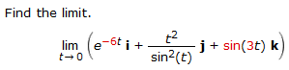

**(13.1.3)**



**(13.1.4)**



**(13.1.5)**



**(13.1.6)**



Hint: Try wolframalpha.com with input: “parametric <cos(t)sin(2t),sin(t)sin(2t),cos(2t)>”

**(13.1.1 solution)**

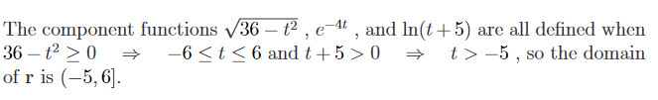

**(13.1.2 solution)**

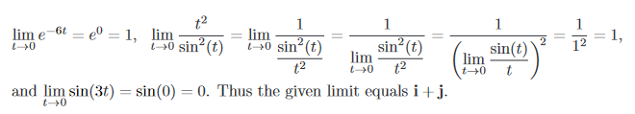

**(13.1.3 solution)**



**(13.1.4 solution)**

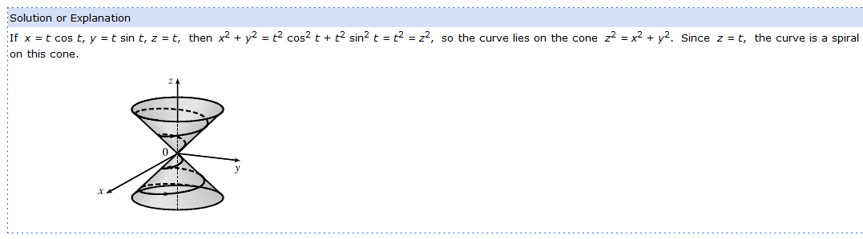

**(13.1.5 solution)**

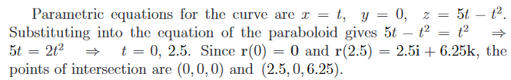

**(13.1.6 solution)**

