**Math 163  
12.6: Quadric Surfaces   
Questions for flipped class**

**(12.6.1)**



**(12.6.2)**



**(12.6.6)**

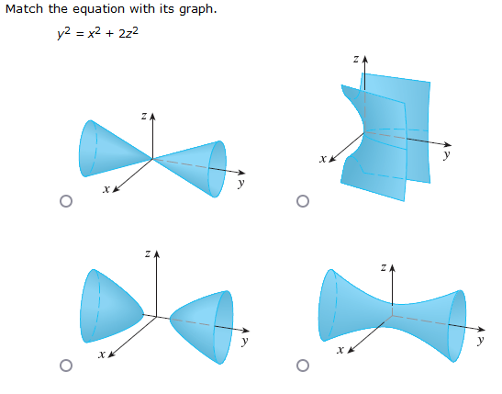

**(12.6.5)**



**(12.6.3)**



**(12.6.4)**



**(12.6.1 solution)**



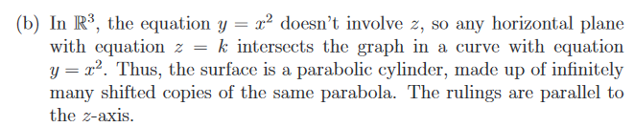

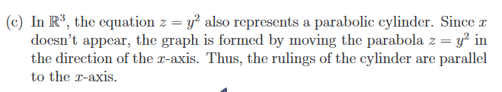

**(12.6.2 solution)**

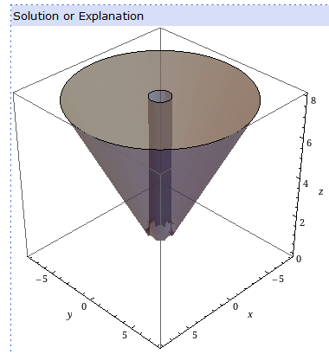

**(12.6.3 solution)**

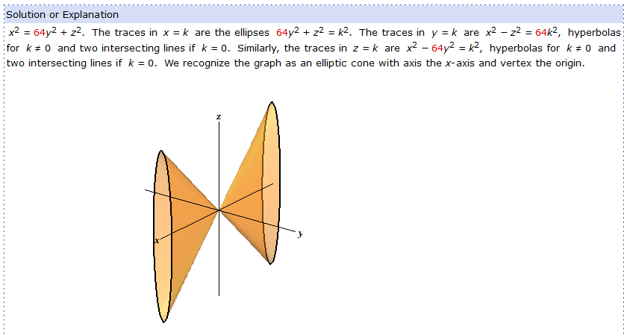

**(12.6.4 solution)**

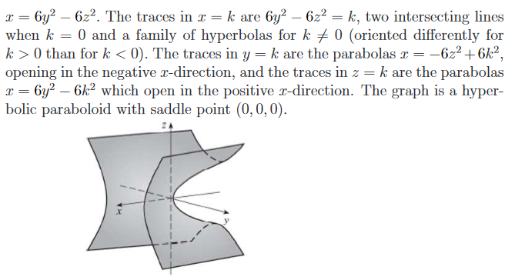

**(12.6.5 solution)**

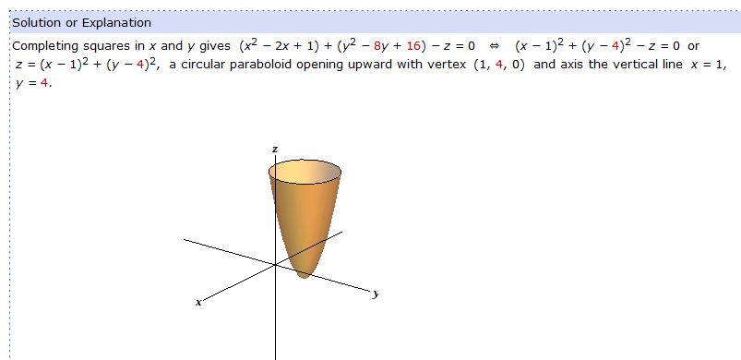

**(12.6.6 solution)**

