**Math 163  
12.5 Questions for flipped class**

**(12.5.1)**

Find an equation of the plane through the point (4,-5,-1) and parallel to the plane 2x – y – z = 7

**(12.5.2)**

Find an equation of the plane through the points (2,-1,3), (7,4,6), and (-2,-3,-2)

**(12.5.3)**

Two roof planes meet at a 90-degree angle at a point 8 feet about the ground. The first roof plane has a 5:12 pitch and the second a 6:12 pitch. (a.) Find a vector pointing in the direction of the valley. (b.) Find a vector perpendicular to the first roof plane. And (c.) find an equation to represent the second roof plane.

**(12.5.4)**

Find a vector equation and parametric equations for the line through the point (1,0,5) and perpendicular to the plane x+3y +z = 1

**(12.5.5)**

Find parametric equations and symmetric equations for the line through (3,3,0) and perpendicular to both **i**+**j** and **j**+**k**.

**(12.5.10)**

Find symmetric equations for the line of intersection of the planes 6x -3y -3z = 0 and 3x + y + z = 5

**(12.5.6)**



**(12.5.7)**



**(12.5.8)**



**(12.5.9)**



**(12.5.1 solution)**

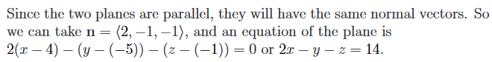

**(12.5.2 solution)**

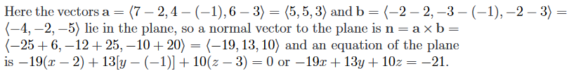

**(12.5.3 solution)**

**(12.5.4 solution)**

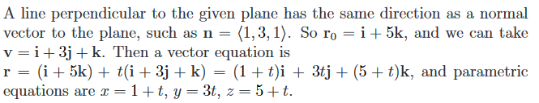

**(12.5.5 solution)**

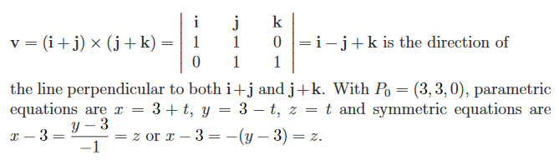

**(12.5.6 solution)**

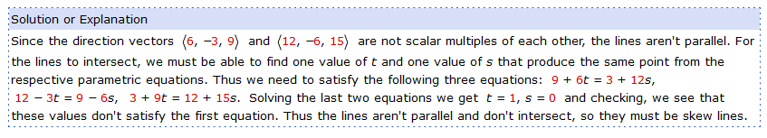

**(12.5.7 solution)**

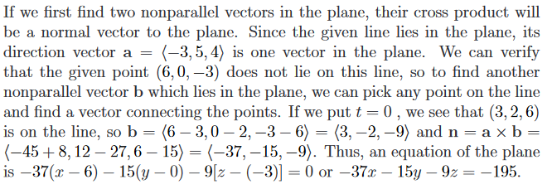

**(12.5.8 solution)**

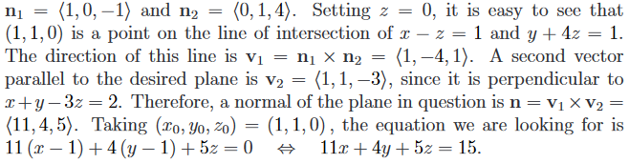

**(12.5.9 solution)**

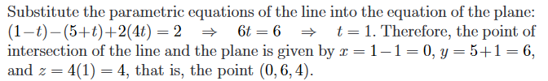

**(12.5.10 solution)**

