**Math 163  
12.3 Questions for flipped class**

**(12.3.1)**



**(12.3.2)**



**(12.3.3)**

Two roof planes on my house meet at a 90-degree angle. Both roof systems have a 5:12 pitch. (a.) Find a vector pointing in the direction of the valley. (b.) find the angle between the valley and a line going straight up one of the roof planes. And (c.) what is the pitch of the valley where the two roof planes meet?

**(12.3.4)**



**(12.3.5)**



**(12.3.6)**



**(12.3.1 solution)**

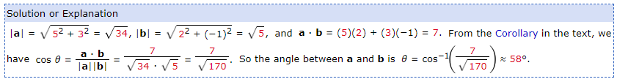

**(12.3.2 solution)**

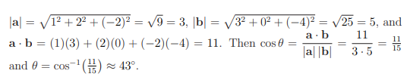

**(12.3.3 solution)**

(a.) If a=<12,0,5> goes straight up Plane A and b=<0,12,5> goes straight up Plane B, then v=<12,12,5> would be parallel to the valley. In order to determine the pitch, we need the horizontal length to be normalized to 12. So we focus on <12,12> which has a length of sqrt(288). Multiplying the vector by 12/sqrt(288)=1/sqrt(2) gives us the vector <12/sqrt(2), 12/sqrt(2), 5/sqrt(2)>. The horizontal distance traveled is 12 and the rise is about 3.5. So the pitch of the valley is about 3.5:12.

(b.) To find the angle, we need to use the previous result to find the angle between a=<12,0,5> and v=<12,12,5>. Recall a.v=|a||v|cos(q). So 169=13.sqrt(313)cos(q) and q=arccos(13/sqrt(13))=27.7 degrees (approx.).

Note: We could also have used b=<0,12,5> in part (b.).

**(12.3.4 solution)**

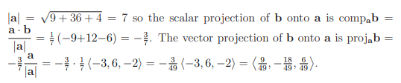

**(12.3.5 solution)**

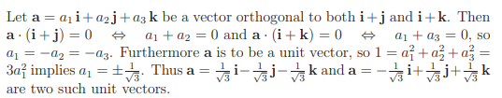

**(12.3.6 solution)**

