**Math 163  
12.1 Questions for flipped class**

**(12.1.1)**

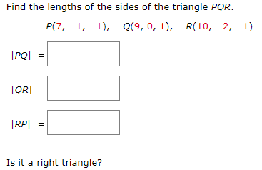

**(12.1.2)**

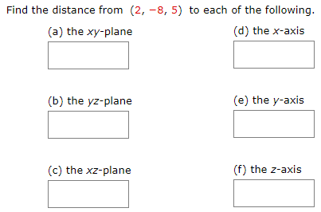

1. The xy-plane
2. The yz-plane
3. The xz-plane
4. The x-axis
5. The y-axis
6. The z-axis

**(12.1.3)**

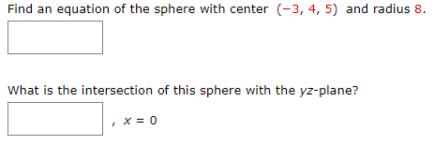

**(12.1.4)**

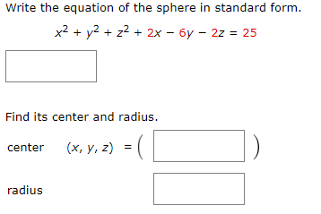

**(12.1.5)**



**(12.1.6)**



**(12.1.1 solution)**

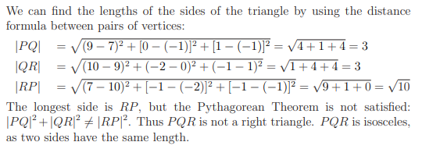

**(12.1.2 solution)**

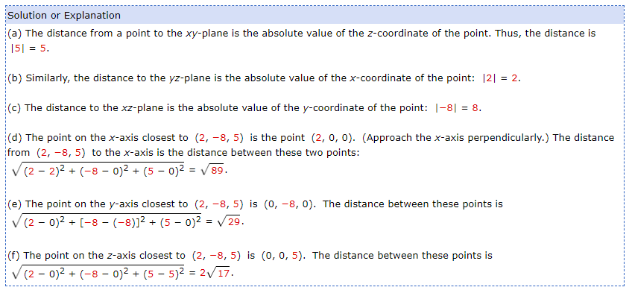

**(12.1.3 solution)**

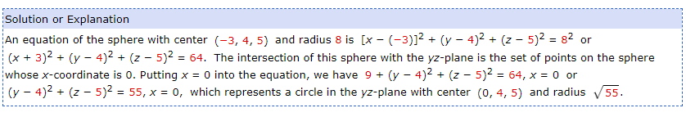

**(12.1.4 solution)**

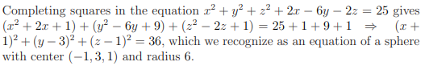

**(12.1.5 solution)**

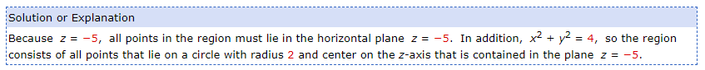

**(12.1.6 solution)**

