Remember that a homogeneous system of equations



can be written in matrix form as  where

 The solution set is all the vectors that satisfy the matrix equation. We are going to name this set of solutions the _________ ______________.

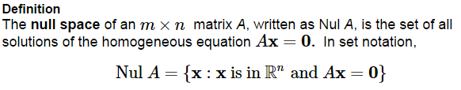

Let A be the matrix defined above. Determine whether the vector   
belongs to the null space of A.

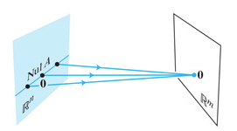

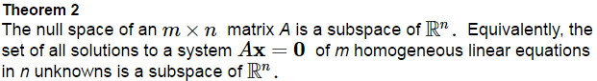 **Proof:**

Let H be the set of vectors in  whose coordinates a, b, and c satisfy the equations ___________________________ and ____________________________. Show that H is a subspace of . *(*Hint*: Create two dependence relations.)*

Find a spanning set for the null space of the matrix .

Two properties of null spaces that contain nonzero vectors that we see from the last example.

1. The spanning set generated using the previous method is automatically ___________________ ________________.
2. The number linearly independent vectors in the spanning set of Nul A equals the number of _________ ________________ in the equation .

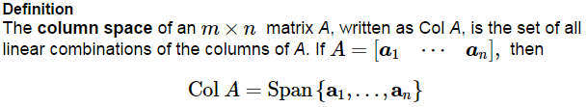





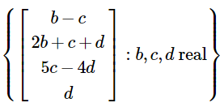Find a matrix A such that .





Given the matrix , answer the following.

1. Find  such that Nul A is a subspace of .
2. Find  such that Col *A* is a subspace of .
3. Find an example of a nonzero vector in Nul *A* as well as Nul *A*.

1. Find a nonzero vector in Col *A*.
2. Is  in the Nul *A?* Is  in the Nul *A*?
3. Is  in Col *A*?

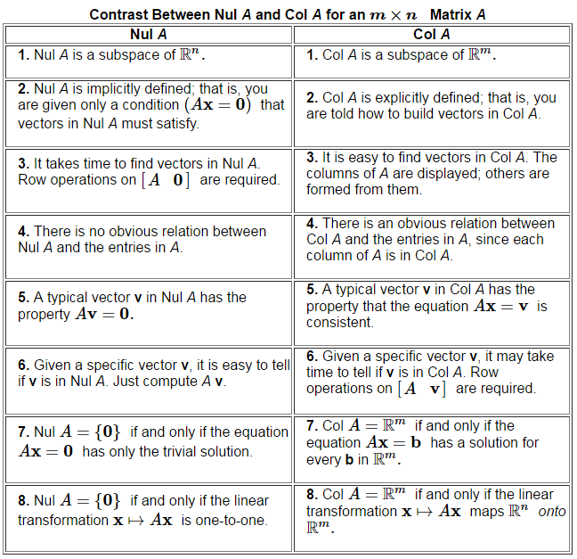

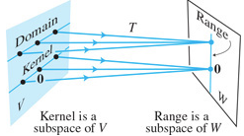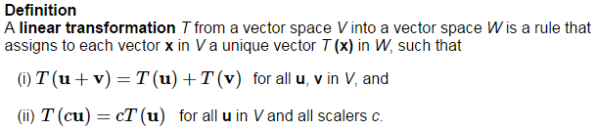

The null space of a linear transformation is called the ____________ and is the set if all vectors  such that .  
The ____________ of T is the set of all vectors in *W* of the form  for some .

