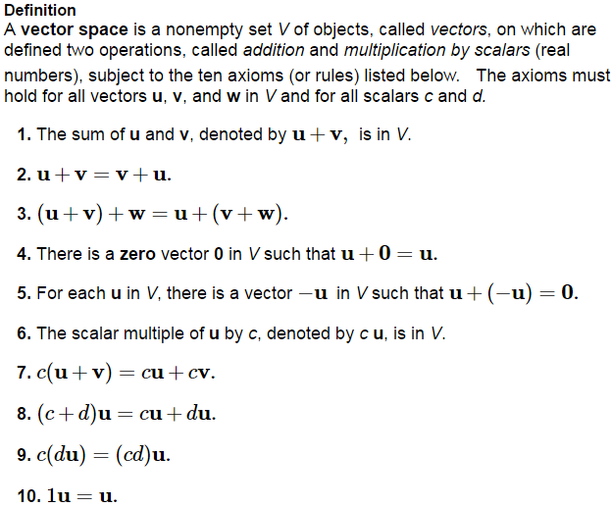

It also follows that

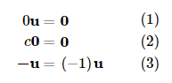

The spaces ________________ for  are the best examples of vector spaces. We will picture ______________ for much of our discussion of vector spaces.

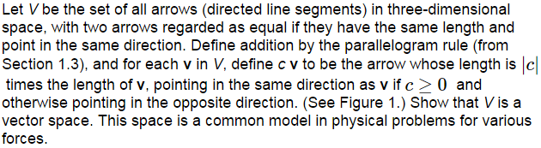

***Read Example 3 on page 193***

Discuss whether the set  of polynomials of degree at most *n* is a vector space.

***Read Example 5 on page 194***

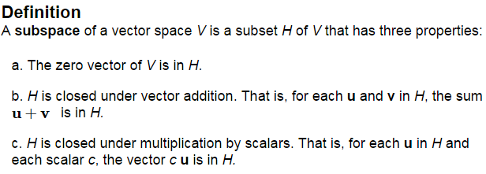

**Note: Every subspace is itself a Vector space.**

The set of just the ________ vector in a vector space *V* is a subspace of V called the ____________ ____________________ and written _________.

Discuss that P, set of all polynomials and a subspace of the set of all real-valued functions, and  is a subspace of *P*.

What about a plane not through the origin? Or a line in  not through the origin? Are they Subspaces? (of  and  respectively).

The vector space  is NOT a subspace of , but *H* is. Discuss.

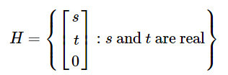

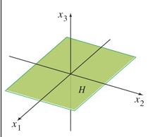



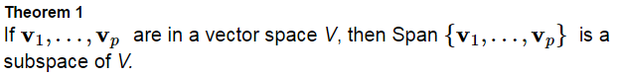

We call this subspace the ________________ ______________________ by 

And for any subspace *H*, we call the set  such that , the __________________ _________.

Let H be the set of all vectors of the form where *a* and *b* are arbitrary scalars. Show that *H* is a subspace of 

We can think of the vectors in a spanning set as the “handles” that define a subspace H, and allow us to hold it and work with it.

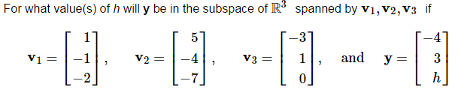

(This is the same example in the text from 1.3 – now with the context of subspaces.)

