**Math 220  
6.5&6: Least Squares and Applications  
Questions for flipped class**

**Important terms**To find a least-squares solution, row reduce:

To find least-squares solutions, construct *A* matrices and the *b* vector:

(1.) Find the equation  of the least-squares line that best fits the data points. 

(2.) Find the quadratic regression equation  of the least-squares line that best fits the data points. .

(3.) A certain experiment produces the data (1, 7.9), (2, 5.4), 3, -0.9). Describe the model that produces a least-squares fit of these points by a function of the form .

(6.5.1)



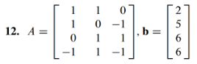

(6.5.2)



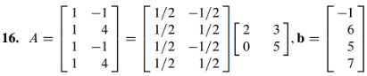

(6.5.3)



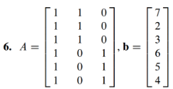

(6.6.1)





(6.6.2)

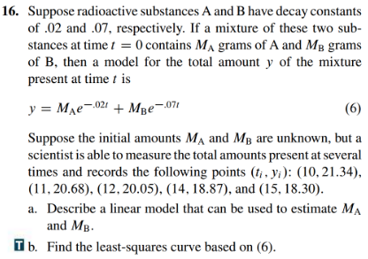

(6.5.6)

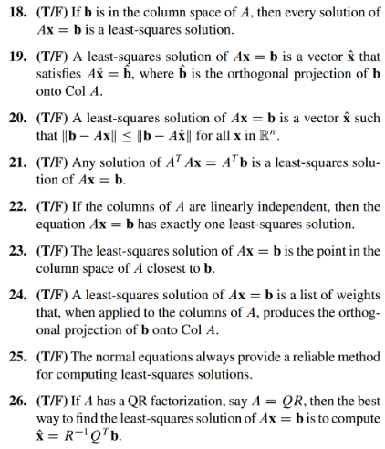

(6.5.1 solution)

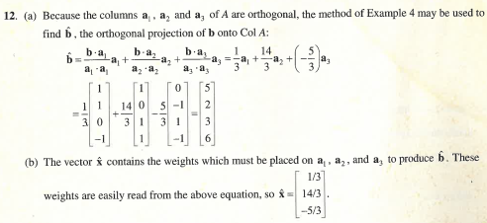

(6.5.2 solution)

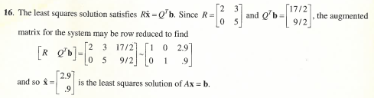

(6.5.3 solution)

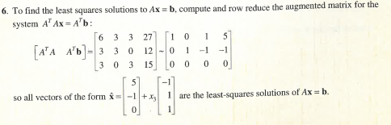

(6.6.1 solution)

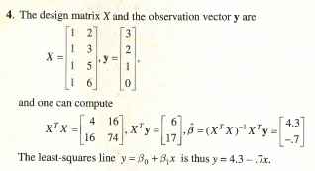

(6.6.2 solution)

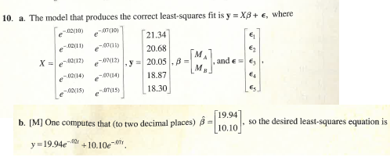

(6.5.6 solution)

