**Math 220  
6.2: Orthogonal Sets and 6.3: Orthogonal Projections  
Questions for flipped class**

**Graphically understand how to find an orthonormal basis in two dimensions**.

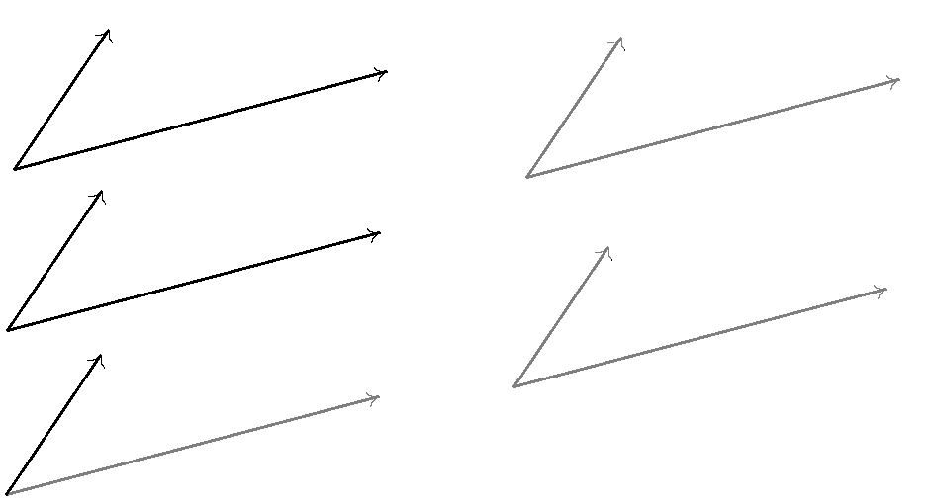

(6.2.7)

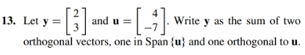

(6.3.1)



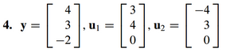

(6.2.8)

Show that is an orthogonal basis for . Then express  as a linear combination of the 

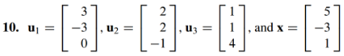

(6.2.9)



Hint: What is the definition of an orthogonal matrix? And then use Theorem ___.

(6.3.2)



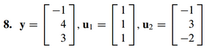

(6.3.3)

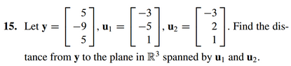

**Graphically understand how to find an orthonormal basis in two dimensions**.

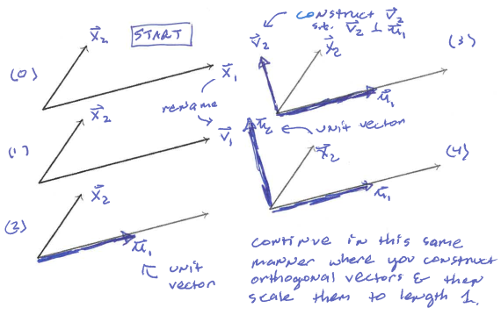

(6.2.7 solution)

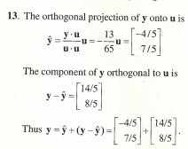

(6.2.8 solution)

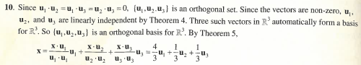

(6.2.9 solution)

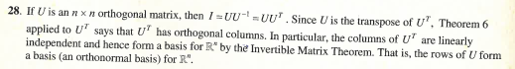

(6.3.1 solution)

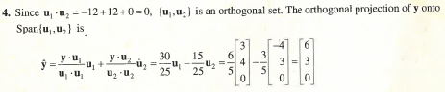

(6.3.2 solution)

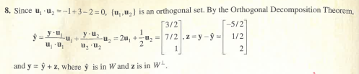

(6.3.3 solution)

