**Math 220  
6.1: Inner Product, Length, and Orthogonality  
Questions for flipped class**

**Important terms**Orthogonal projection:  
  
  
  
  
:

(6.1.1)

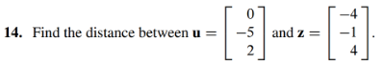

(6.1.2)



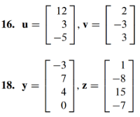

(6.1.3)



(6.1.4)

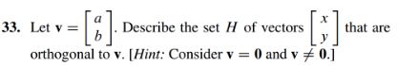

(6.1.5)

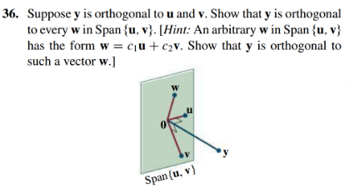

(6.1.6)

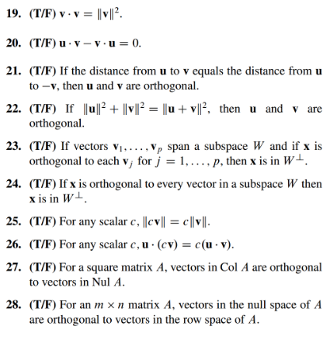

(6.1.1 solution)

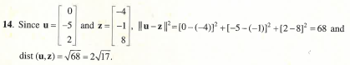

(6.1.2 solution)

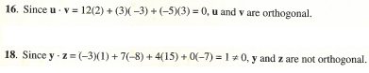

(6.1.3 solution)



(6.1.4 solution)

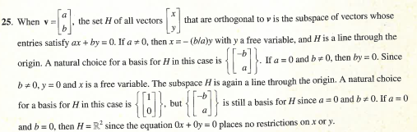

(6.1.5 solution)



(6.1.6 solution)

