**Math 220  
5.3: Diagonalization  
Questions for flipped class**

**Important terms**Similar matrices:  
  
  
  
  
Diagonalizable matrices:

(5.3.1)



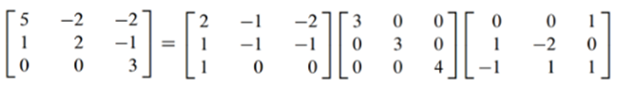

(5.3.2)

Diagonalize the matrix below given that one eigenvalue is  and one eigenvector is 



(5.3.3)

Diagonalize (if possible), the matrix below



(5.3.4)

Diagonalize (if possible), the matrix below

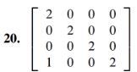

(5.3.5)

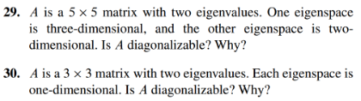

(5.3.6)

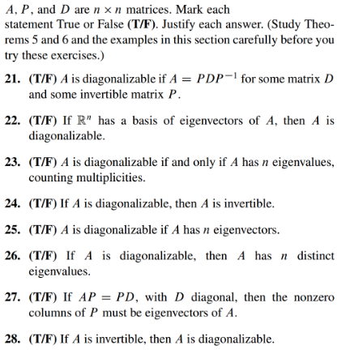



Similar matrices:  
  
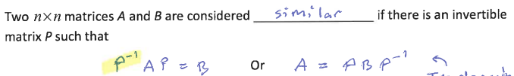  
  
Diagonalizable matrices:

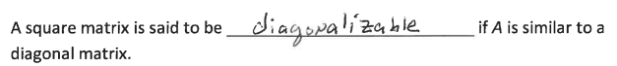

Notice that the ith column of P is the eigenvector whose corresponding eigenvalue is in the ith column of D.

(5.3.1 solution)

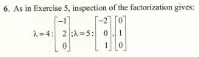

(5.3.2 solution)

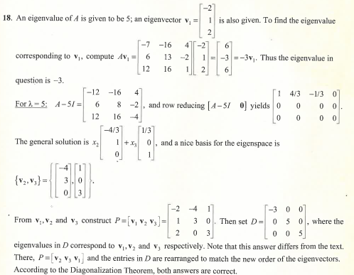

(5.3.3 solution)

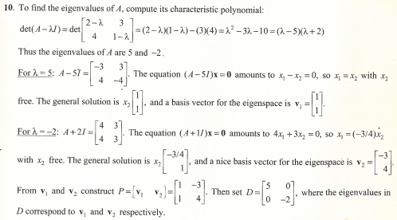

(5.3.4 solution)

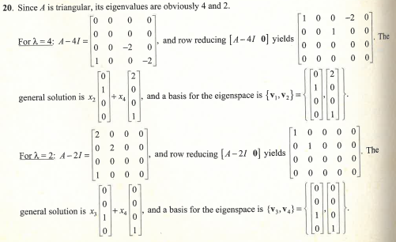

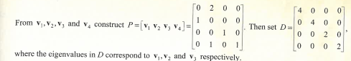

(5.3.5 solution)

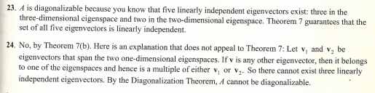

(5.3.6 solution)

