**Math 220  
5.2: The Characteristic Equation  
Questions for flipped class**

**Important terms**Characteristic polynomial:  
  
  
  
  
Similar matrices:

(5.2.1)





(5.2.2)

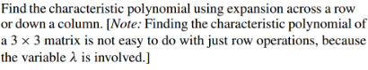

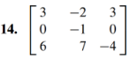

(5.2.3)





What is the algebraic multiplicity of the eigenvalue(s)?

(5.2.4)



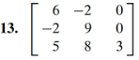

Use this to find the eigenvalues and their algebraic multiplicity

(5.2.5)

Find (1.) the eigenvalues, their (2.) multiplicities, and (3.) the corresponding eigenspaces.

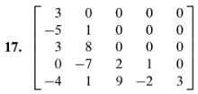

(5.2.6)

Assume *A* and *B* are *n* x *n* matrices

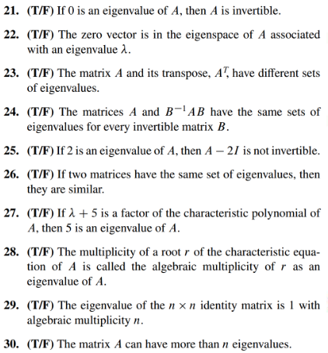

(5.2.1 solution)

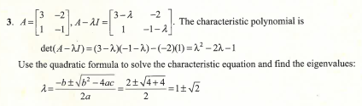

(5.2.2 solution)

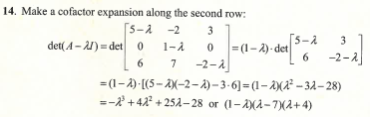

(5.2.3 solution)

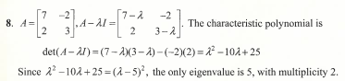

(5.2.4 solution)

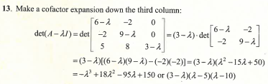

(5.2.5 solution)

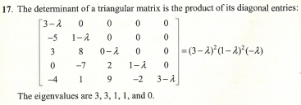

(5.2.6 solution)

