**Math 220  
4.4b: Coordinate Systems  
Questions for flipped class**

(4.4.1)



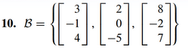

(4.4.2)





(4.4.3)



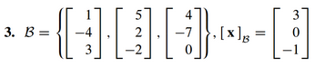

(4.4.4)



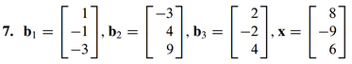

(4.4.5)

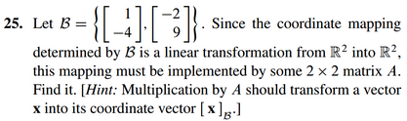

(4.4.6)

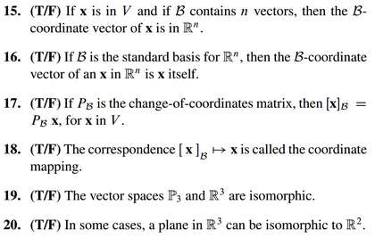

(4.4.1 solution)

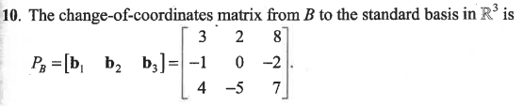

(4.4.2 solution)

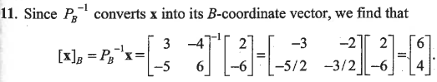

(4.4.3 solution)

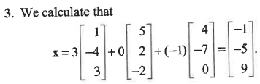

(4.4.4 solution)

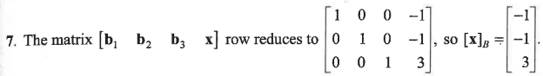

(4.4.5 solution)



(4.4.6 solution)

