**Math 220  
4.4a: Coordinates  
Questions for flipped class**

**Important terms**Mapping:   
  
  
  
  
Isomorphic:

(4.4.1)





(4.4.2)





(4.4.3)





(4.4.4)





(4.4.5)

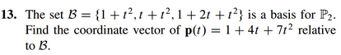

(4.4.6)





Note: “Explain” requires words😊.

Mapping: There’s not much of a difference. A “map” is slightly more general, insofar as it allows a many-to-one situation. That is, a “function” is a map from a domain D to a range R such that each element of D has exactly one image in R . Replace “exactly” with “at least one,” and you have a map.

Perhaps the poster child of a (useful) many-to-one mapping is the square root map. Recall, we can’t really talk about the square root of 4. We can talk about a square root of 4. But there are two of them: 2 and -2. In middle school algebra, we conveniently forget about that fact promptly: we say that the symbol (√4) represents the positive square root, and thereby resolve the ambiguity.

The same thing sometimes happens with other functions, like inverse trigonometric functions. When the input value is allowed to be complex, the same thing happens with logarithms and exponentials. In each case, a similar trick to “picking the positive value” can be used to resolve the ambiguities, although sometimes it’s a little tricky to do so.

Isomorphism: In mathematics, an isomorphism is a structure-preserving mapping between two structures of the same type that can be reversed by an inverse mapping. Two mathematical structures are isomorphic if an isomorphism exists between them. The word isomorphism is derived from the Ancient Greek: isos "equal", and morphe "form" or "shape".

(4.4.1 solution)

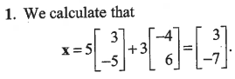

(4.4.2 solution)



(4.4.3 solution)

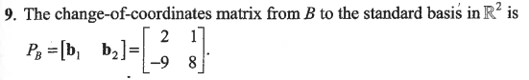

(4.4.4 solution)

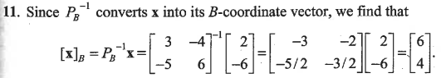

(4.4.5 solution)

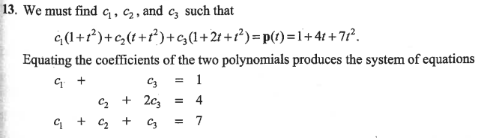

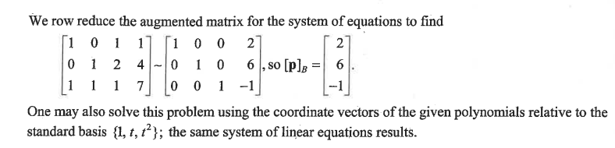

(4.4.6 solution)

