**Math 220  
4.3: Linearly Independent Sets; Bases  
Questions for flipped class**

(4.3.1)



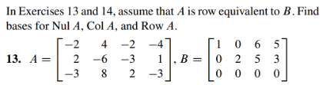

Note: An example of a row vectors is: . Notice that we use parenthesis instead of brackets and include commas between the entries.

(4.3.2)



Note: “Bases” is the plural of “basis.”

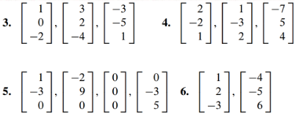

(4.3.3)



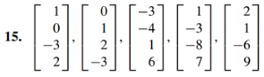

(4.3.4)

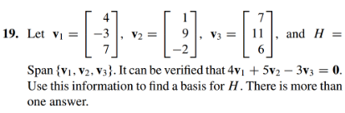

(4.3.5)

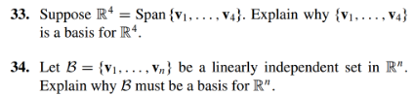

(4.3.6)

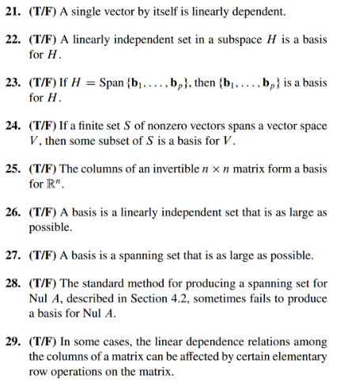

(4.3.1 solution)

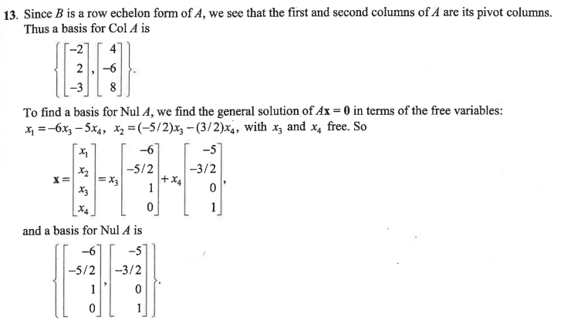

(4.3.2 solution)

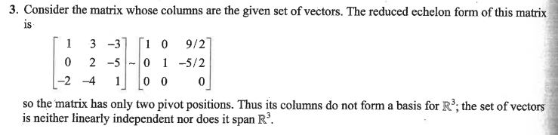

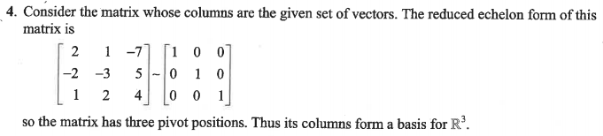

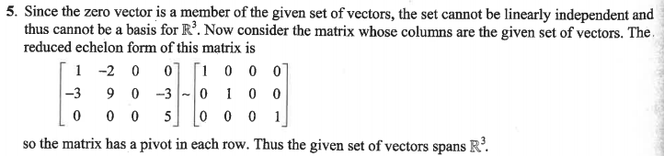

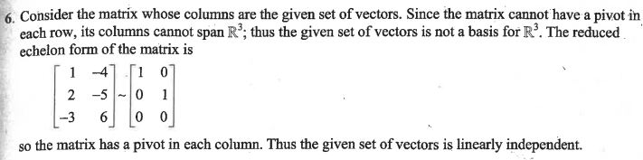

(4.3.3 solution)

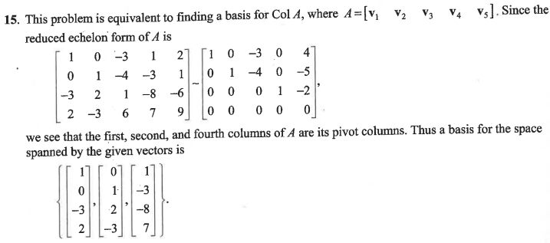

(4.3.4 solution)

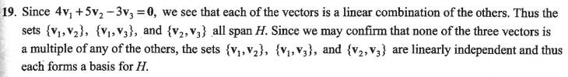

(4.3.5 solution)

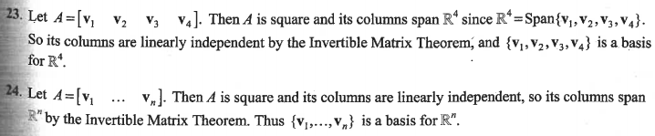

(4.3.6 solution)

