**Math 220  
4.2a: The Null and Column Space  
Questions for flipped class**

**Important terms**Null Space of a matrix (aka, The Kernel of a Linear Transformation)  
  
  
  
  
Column Space of a matrix (aka, The Range of a Linear Transformation)

(4.2.1)

Find an explicit description of Nul *A* by listing vectors that span the null space.



(4.2.2)

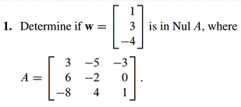

(4.2.3)

Find an explicit description of Nul *A* by listing vectors that span the null space.

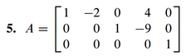

(4.2.4)



(review of 4.1: 4.2.5)

Either use an appropriate theorem to show that the given set, *W*, is a vector space, or find a specific example to the contrary.

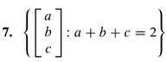

(review of 4.1: 4.2.6)

Either use an appropriate theorem to show that the given set, *W*, is a vector space, or find a specific example to the contrary.

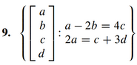

(4.2.1 solution)

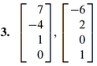

(4.2.2 solution)

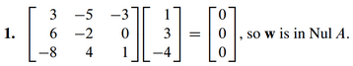

(4.2.3 solution)

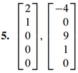

(4.2.4 solution)



(review of 4.1: 4.2.5 solution)



(review of 4.1: 4.2.6 solution)

