**Math 220  
3.1&2: The Determinant  
Questions for flipped class**

**Important terms**Diagonal  
  
  
  
  
Upper and lower triangular matrices

(3.1.1)

Calculate the determinant (calculated by hand)

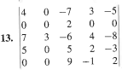

(3.1.2)

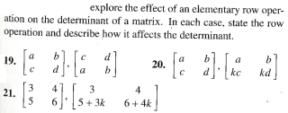

(3.1.3)

Use determinants (calculated by hand) to determine if the matrix is invertible

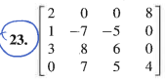

(3.1.4)

Use determinants (calculated by hand) to determine if the vectors are linearly independent

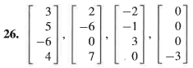

(3.1.5)



(3.1.6)

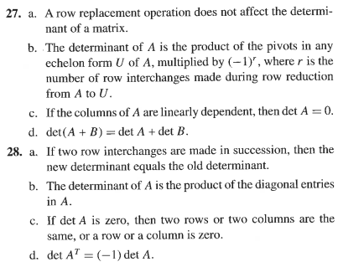

(3.1.7 theory question)



(3.1.1 solution)

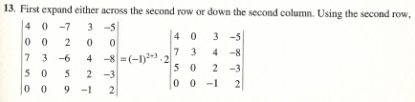

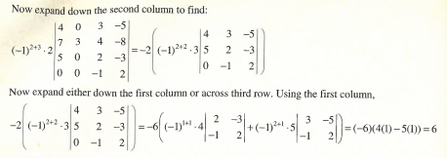

(3.1.2 solution)

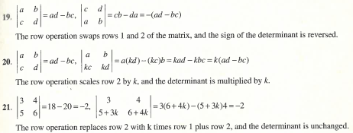

(3.1.3 solution)

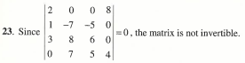

(3.1.4 solution)

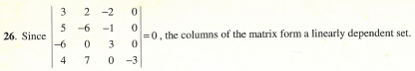

(3.1.5 solution)

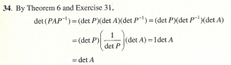

(3.1.6 solution)



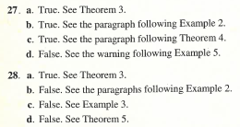

(3.1.7 proof)

