**Math 220  
2.2: The Inverse of a Matrix   
Questions for flipped class**

**Important terms**What is the short cut formula for finding the inverse of a 2x2 matrix?  
  
  
  
  
Does this formula work for matrices with other dimensions?

**Calculator Instruction**: Use RREF to find the matrix inverse (or use the formula for 2x2 cases).

(2.2.1)

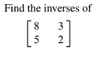

(2.2.2)

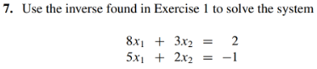

(2.2.3)



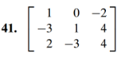

(2.2.4)



(2.2.5)



(2.2.6)

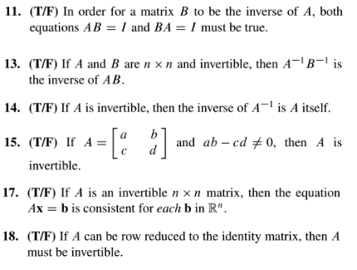

(2.2.7 theory question)

Prove Theorem 5

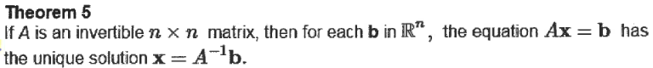

(2.2.1 solution)



(2.2.2 solution)



(2.2.3 solution)

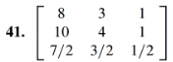

(2.2.4 solution)

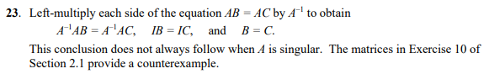

(2.2.5 solution)

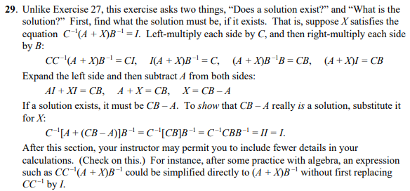

(2.2.6 solution)

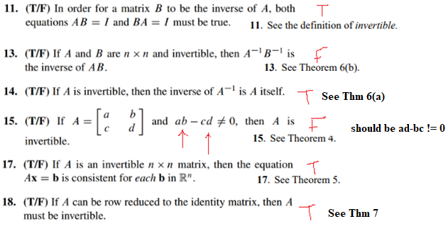

(2.2.7 proof)

