**Math 220  
1.9: The Matrix of a Linear Transformation**

**Questions for flipped class**

**Key terms**:

One-to-one

Onto

(1.9.1)

Assume that *T* is a linear transformation. Find the standard matrix of *T*.



(1.9.2)

Assume that *T* is a linear transformation. Find the standard matrix of *T*.



(1.9.3)

Assume that *T* is a linear transformation. Find the standard matrix of *T*.

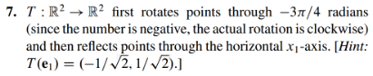

(1.9.4)

Show that *T* is a linear transformation by finding a matrix that implements the mapping. Note that the x’s are not vectors, but are entries in vectors.



(1.9.5)

Show that *T* is a linear transformation by finding a matrix that implements the mapping. Note that the x’s are not vectors, but are entries in vectors.



(1.9.6)

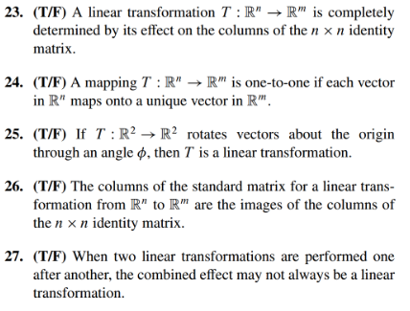

(1.9.7 theory question)

Prove the following:



(1.9.1 solution)

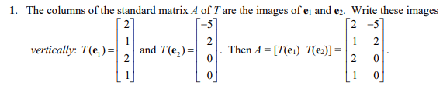

(1.9.2 solution)



(1.9.3 solution)

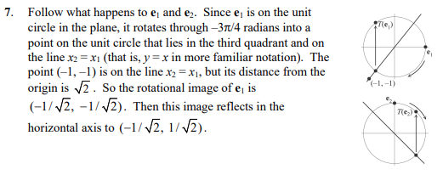

(1.9.4 solution)

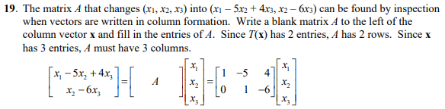

(1.9.5 solution)

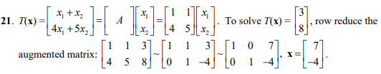

(1.9.6 solution)

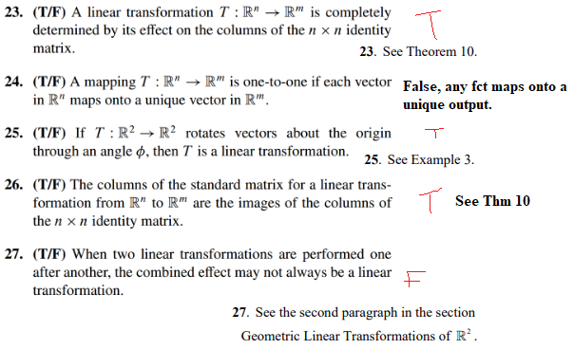

(1.9.7 proof)

