**Math 220  
1.8 Linear Transformations  
Questions for flipped class**

**Key terms**:

Standard basis vectors: , , …

Definition of a Linear Transformation

(1.8.1)

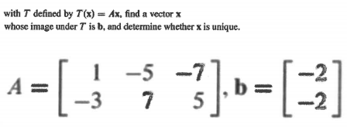

(1.8.2)



(1.8.3)

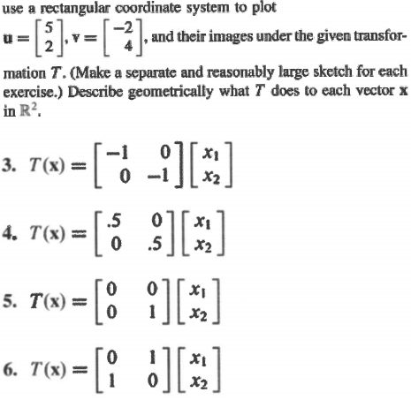

(1.8.4)

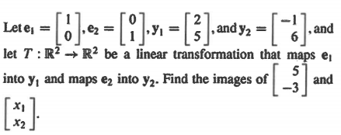

(1.8.5)

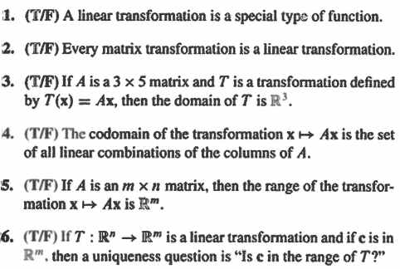

(1.8.6)

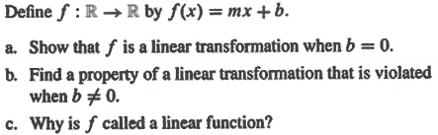

(1.8.7 theory question)

How will we begin showing a function is a linear transformation? That is, what are the assumptions/definitions we will make at the outset?

(1.8.1 solution)



(1.8.2 solution)



(1.8.3 solution)

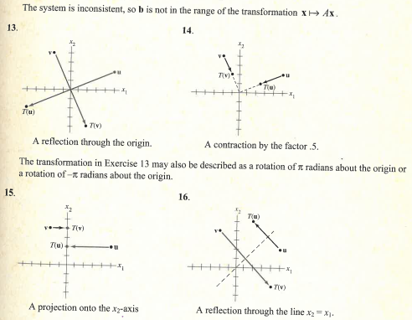

(1.8.4 solution)



(1.8.5 solution)

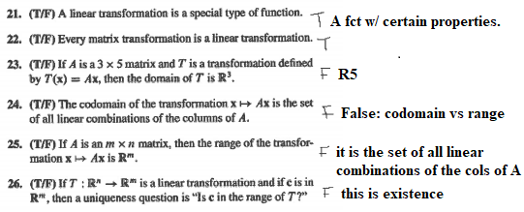

(1.8.6 solution)

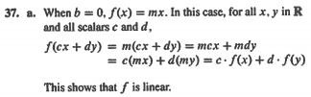

(1.8.7 theory solution)

How will we begin showing a function is a linear transformation? That is, what are the assumptions/definitions we will make at the outset?

Claim: T: X -> Y is a linear transformation.

Let T be as given above and scalar *c* and u,v in X be given.