**Math 220  
1.6: Applications of Linear Systems  
1.7: Linear Independence   
Questions for flipped class**

**Key terms**:

Linearly independent

Linearly dependent

What is the connection between linear dependence/independence and the homogeneous equation?

(1.6-7.1)



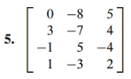

(1.6-7.2)



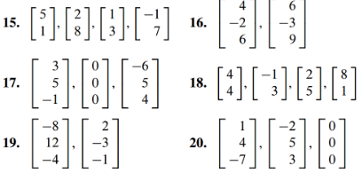

(1.6-7.3 application from section 1.6)

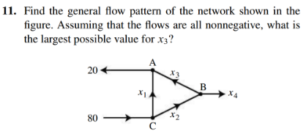

(1.6-7.4)





(1.6-7.5)

True or false. If it is false, provide a counter example (a specific example that shows that the statement isn’t always true).



(1.6-7.6)

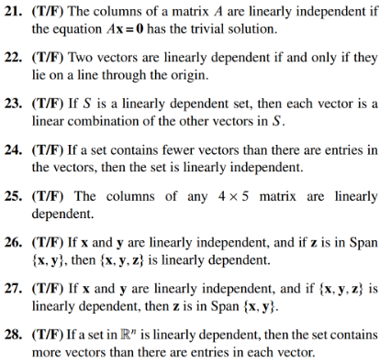

(1.6-7.7 theory question)

Prove Theorem 8 (if-then proof)

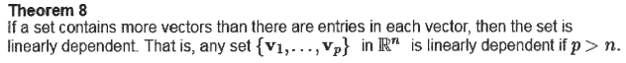

(1.6-7.8 theory question)

Prove Theorem 8 (if and only if proof)

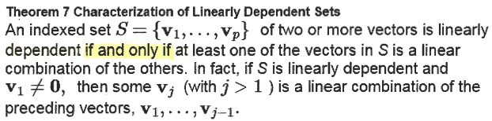

(1.6-7.1 solution)



(1.6-7.2 solution)



**16.** Lin dep. **18**. Lin. Dep. **20.** Lin dep.

(1.6-7.3 solution)

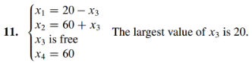

(1.6-7.4 solution)

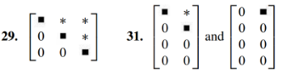

(1.6-7.5 solution)



False, for example the vectors could be e1, e2, e3, and e1. This is a linearly dependent set.

(1.6-7.6 solution)

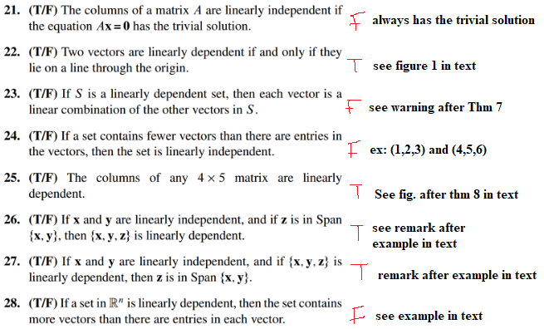

(1.6-7.7 proof)

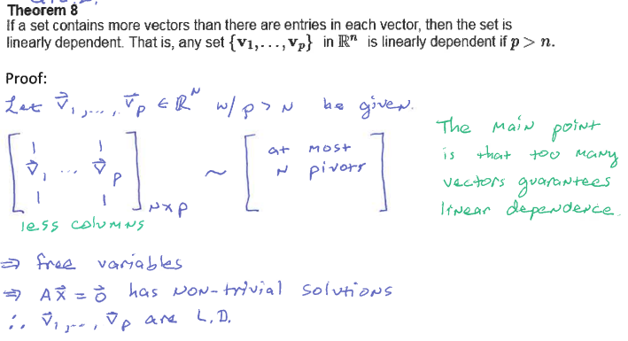

(1.6-7.8 proof)

