**Math 220  
1.3: Vector Equations  
Questions for flipped class**

**Key terms**:

Linear combination

Span

(1.3.1)

Sketch carefully and try to maintain the scale.





(1.3.2)

Write a system of equations AND augmented matrix that is equivalent to the given vector equations.

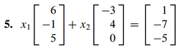

(1.3.3)



(1.3.4)

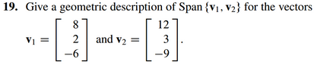

(1.3.5)

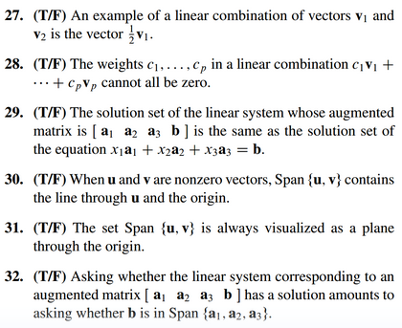

(1.3.6)

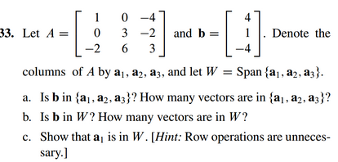

(1.3.7 theory question rehashed)

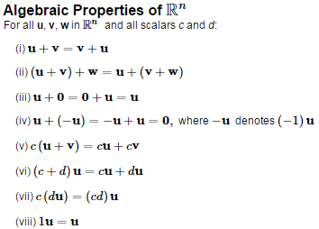

Prove property (i.)

(1.3.8 theory question)

Prove property (vi.)

(1.3.1 solution)



(1.3.2 solution)



(1.3.3 solution)



(1.3.4 solution)



(1.3.5 solution)



(1.3.6 solution)



(1.3.7 theory rehash solution)

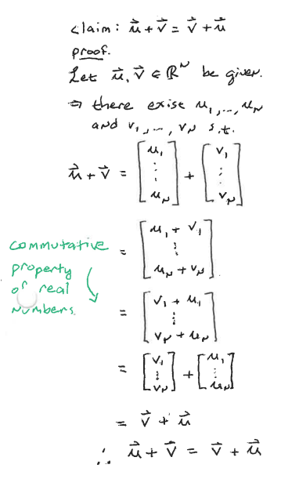

(1.3.7 theory solution)