If *A* is an ** matrix with m rows and n columns, then the entry in the ith row and jth column is denoted by _______ and is called the ________________.

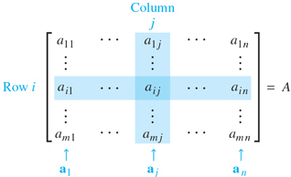

The ____________________ entries are  and they form the _________ ___________________.

A _____________________ matrix is a square matrix (*)* whose non-diagonal entries are all _________________. The ___________________ matrix  is a diagonal matrix with _______ down the diagonal.

The _____________ matrix has all zeros in all of its entries and is written just as 0.

Two matrices are ________________ if they are the same ________ and the corresponding ____________ are ______________.

The ___________ of two matrices ______________ is the _________ of their corresponding ____________. Thus, two matrices can only be _____________ if their __________ ( ) is the same. Otherwise, the sum is not defined.

Given ,  and .   
Find the following, if defined.

1. *A+B* b) *B+C*

The __________________ _______________________ _________ is the matrix whose entries are _____ times each entry of *A*.

The matrix ________ represents ________ and __________ is the same as __________.

Given  and . Find

1. 2*A* b) *B*-2*A*

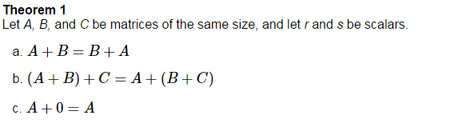

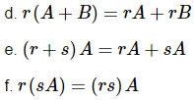

**Matrix Multiplication**

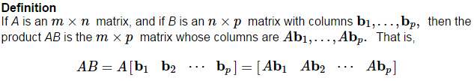

Given  and , compute *CA*.

  

Given  and , is the matrix *AC* defined?

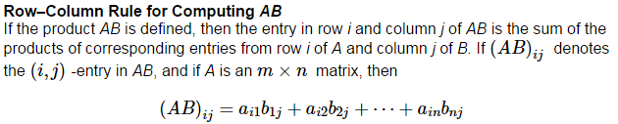

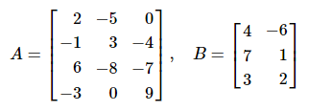Find the entries of the 3rd row of *AB,* where

We could have just ignored the rest of *A* and computed



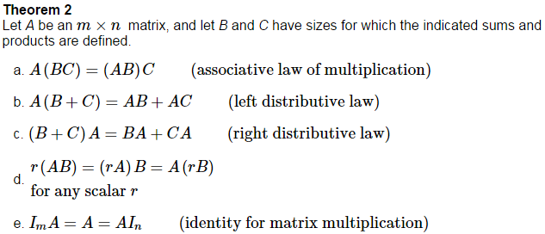

While the following properties are all true, be careful, the ____________________ property is not true, that is, *AB* _____ *BA.*

Let  and . Show that these two matrices do not commute. That is, verify that .

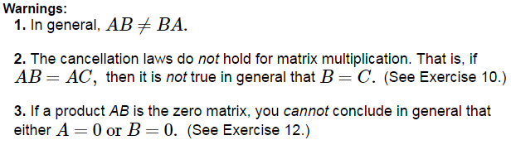





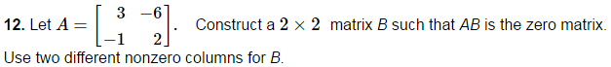

If *A* is an  matrix and if *k* is a positive integer, then 

Given an  matrix *A*, then the ______________________ of *A* is the matrix, denoted by ________ whose ____________________ are formed by the corresponding __________ of *A.*

Let , , and . Find



