**Real Eigenvalues**

A stretch of desert in Northwestern Mexico is populated mainly by two species of animals: coyotes and roadrunners. We wish to model the populations  and  of coyotes and roadrunners *t* years from now if the current populations  and  are known.

From this habitat, the following equations model the transformation of this system from one year to the next, from time *t* to time *t*+1.:



1. Write this as a matrix product 

We call  the ______________________ and  the ______________________

This linear transformation is an example of a ________________________________

1. Suppose we begin with 100 coyotes and 300 road runners, find a close-form formula for .
2. Suppose we have  and , find 
3. Suppose we have , find . Hint: Write  in terms of the eigenbasis.
4. Sketch a phase portrait to describe this system

Here is another example.

Consider . Since the sum of each column is 1, this linear transformation matrix is called a ____________________________.

1. Find a closed-form expression for . Hint: Since *A* is a transition matrix, one of its eigenvalues will be one.
2. If , find 
3. Find the steady-state or equilibrium vector 

**Complex Eigenvalues**

Up to this point, we have only discussed real eigenvalues and real-valued vectors (including eigenvectors). But the linear algebra world we have established works over complex numbers of the form  where .

Find the eigenvalues and a basis for each eigenspace in  of the matrix . Then write the eigenvectors  in the form 

Notice that a real-valued matrix can have complex eigenvalues and eigenvectors. Notice further that the eigenvalues and vectors come in conjugate pairs.

Next we need to unpack the rotation-scaling matrix .

1. Find the eigenvalues of *C*.
2. Let’s call . Then using the picture below, find  and  in terms of .

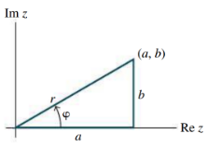

So 

where is a scaling matrix and is a rotation matrix.

The matrix  is a rotation-scaling matrix. Find its eigenvalues, scaling factor, and the angle of rotation .

This brings us back to the idea of matrix factorization. Recall that if *A* had real eigenvalues and enough linearly independent eigenvectors, then  where the columns of *P* were the eigenvectors and *D* was a diagonal matrix whose diagonal entries were the corresponding eigenvalues.

Similarly, let *A* be a real matrix with a complex eigenvalue  and an associated eigenvector  in . Then  where  and *C* is the rotation-scaling matrix .

Find an invertible matrix *P* and a matrix *C* of the form  such that the matrix  has the form 

**Trajectories of Dynamical Systems**

When we began this lesson, we used a predator-prey example involving coyotes and road runners. We ended that example with a phase portrait that helped us understand the trajectories based upon various initial state vectors.

Let’s begin by trying to understand how these trajectories work.

Suppose  and , find and plot 

**(revisited)**  and has eigenvalues  and  with corresponding eigenvectors and .

So if , then 

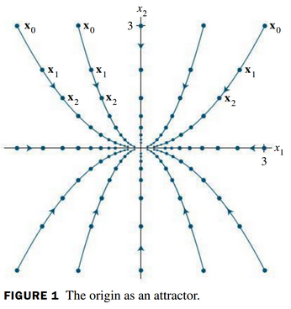

Suppose . What are the eigenvalues and eigenvectors?

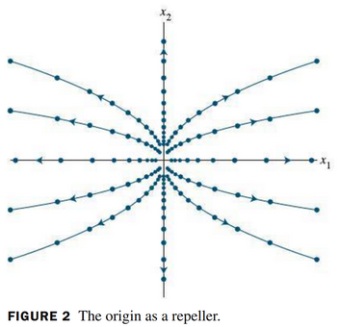

Suppose . Here is a phase portrait for it.

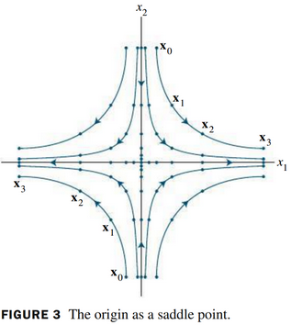

Question: In the previous examples, we have focused on diagonal matrices? Is this reasonable? Is it overly simplistic? Explain.

Show that the origin is a saddle point for the solutions of  where .

Phase portraits get more interesting with complex eigenvalues



Consider the dynamical system and sketch the trajectory of where and  .

