

Calculate  and .

What do you notice about either of them?

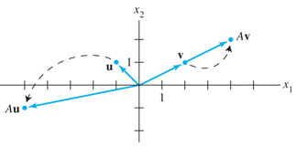

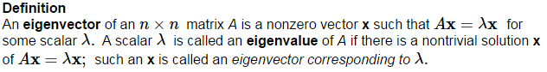

Is an eigenvector of ? If so, find the eigenvalue.

Is an eigenvector of ? If so, find the eigenvalue.

Show that 5 is an eigenvalue of the matrix , and find a corresponding eigenvector.

The eigenvector must be ________________, but an eigenvalue may be __________.

So  is an eigenvalue of an  matrix, if and only if



What would another name for the solutions to this equation be?

But we already know that any __________________ is a ___________________ of , so we call it the _________________________ of *A*.

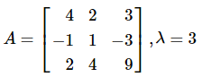

Find a basis for the eigenspace given



Find the eigenvalues of .

What does it mean for a matrix A to have an eigenvalue of 0?

This means that 0 is an eigenvalue of A if and only if A is _______ ______________.

This will be added to our ________________ ______________ _____________ in 5.2.

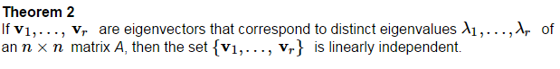

Proof:

