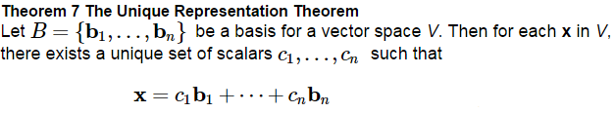

Proof:

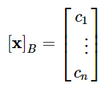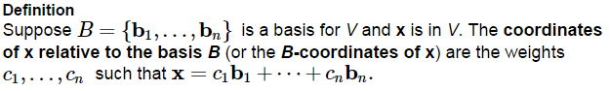

We call this vector the _____________________ __________ ____ ____ ( ________________ ____ ______ ____ )

or the _________________________ __________ ____ ____

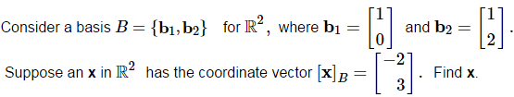is the ______________________ __________________(determined by *B*)

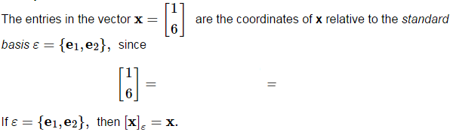

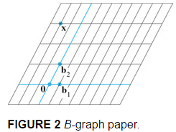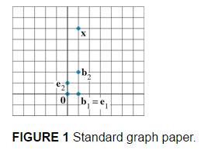

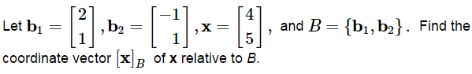***See Example 3 on page 219.***

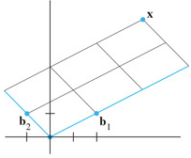

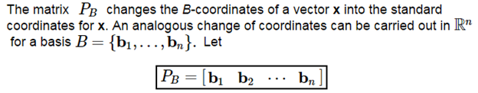

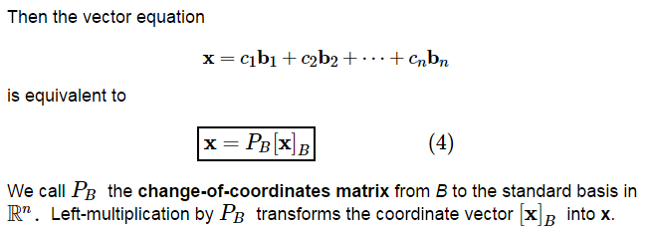

Since the columns of  form a basis, they are linearly independent, and have an inverse, which leads to



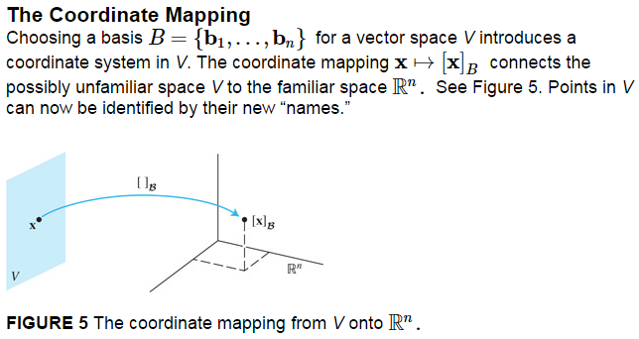

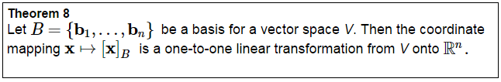

A one-to-one linear transformation from a vector space *V* onto a vector space *W* is called an ____________________________ from *V* onto *W*.

Essentially, these two vector spaces are indistinguishable.

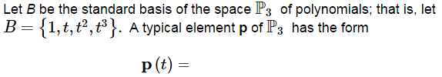

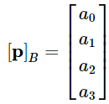

Since p is a linear combination of the standard basis vectors, then



So is an isomorphism

from

Use coordinate vectors to test the linear independence of the sets of polynomials.

1. 



1. Is this a basis for ?

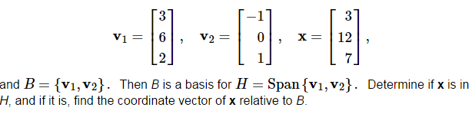

Let

