**Math 220  
6.3: Orthogonal Projections and 6.4: Gram-Schmidt Orthogonalization  
Questions for flipped class**

(6.3.4)

Find the best approximation to  by vectors of the form 

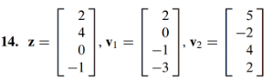

(6.4.1)

Find an orthogonal basis for the column space of the matrix

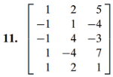

(6.3.5)

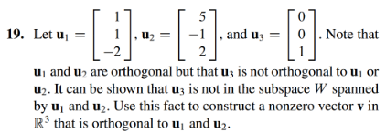

(6.4.2)



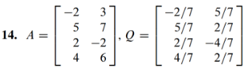

(6.4.3)

Find a QR factorization for the matrix from (6.4.1)

(6.4.4)

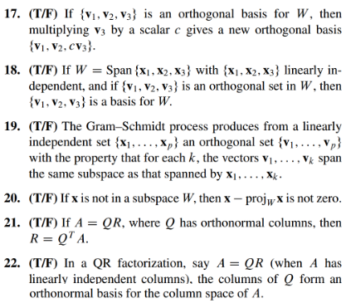

(6.3.6)

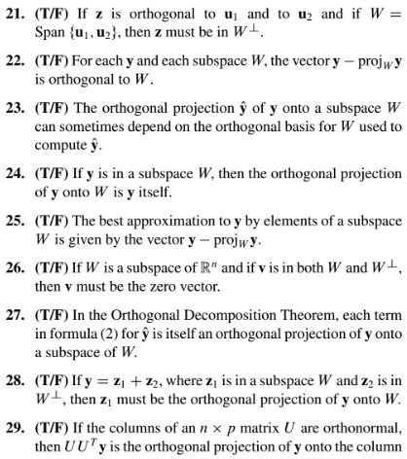

(6.3.4 solution)

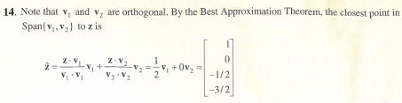

(6.4.1 solution)

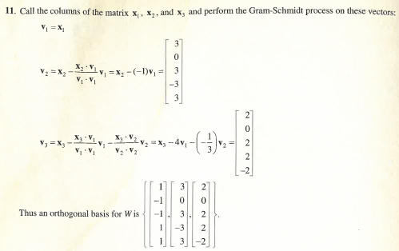

(6.3.5 solution)

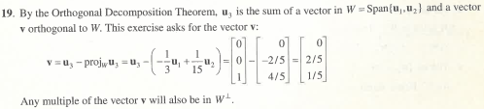

(6.4.2 solution)

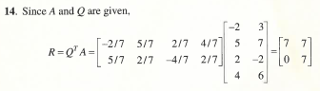

(6.4.3 solution)

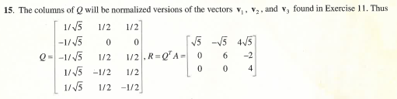

(6.4.4 solution)

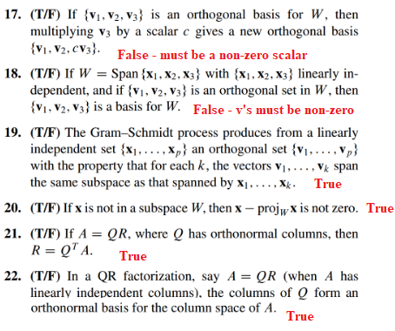

(6.3.6 solution)

