**Math 220  
5.3: Diagonalization  
Questions for flipped class**

(5.3.1)



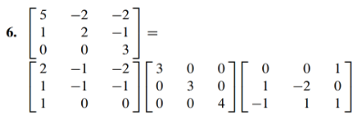

(5.3.2)

Diagonalize given that one eigenvalue is  and one eigenvector is 



(5.3.3)

Diagonalize



(5.3.4)

Diagonalize

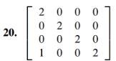

(5.3.5)

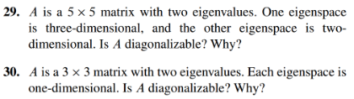

(5.3.6)

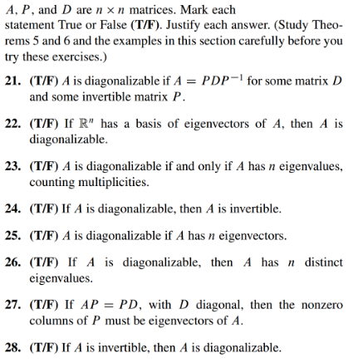

(5.3.1 solution)

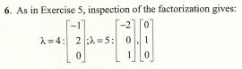

(5.3.2 solution)

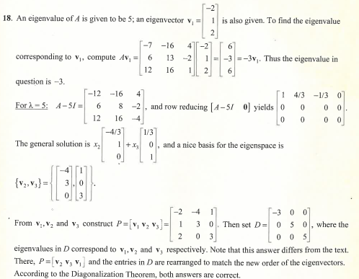

(5.3.3 solution)

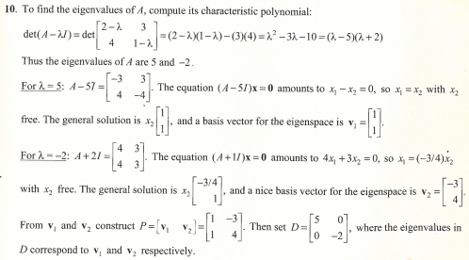

(5.3.4 solution)

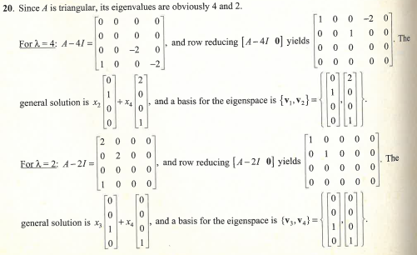

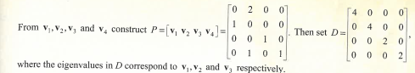

(5.3.5 solution)

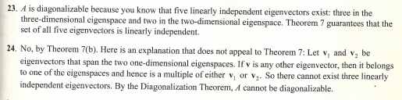

(5.3.6 solution)

