**Math 220  
5.2: The Characteristic Equation  
Questions for flipped class**

(5.2.1)





(5.2.2)

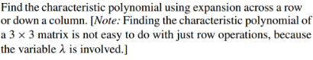

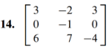

(5.2.3)





What is the algebraic multiplicity of the eigenvalue(s)?

(5.2.4)



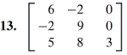

Use this to find the eigenvalues and their algebraic multiplicity

(5.2.5)

Find the eigenvalues, their multiplicities, and the corresponding eigenspaces.

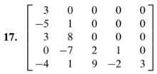

(5.2.6)

Assume *A* and *B* are *n* x *n* matrices

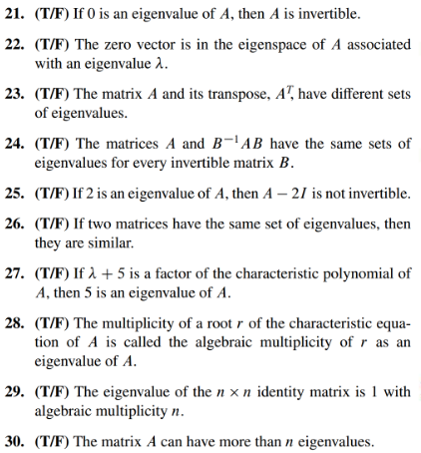

(5.2.1 solution)

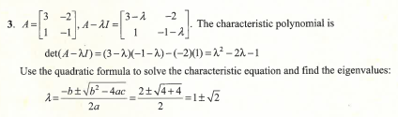

(5.2.2 solution)

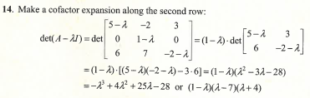

(5.2.3 solution)

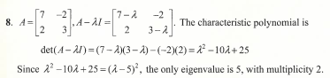

(5.2.4 solution)

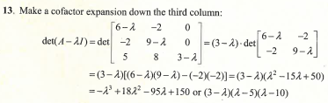

(5.2.5 solution)

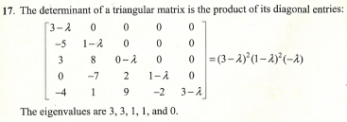

(5.2.6 solution)

