**Math 220  
5.1: Eigenvalues and Eigenvectors  
Questions for flipped class**

(5.1.1)

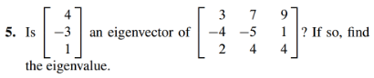

(5.1.2)

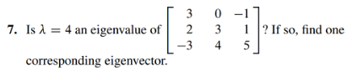

(5.1.3)





(5.1.4)



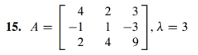

(5.1.5)

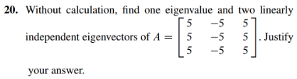

(5.1.6)

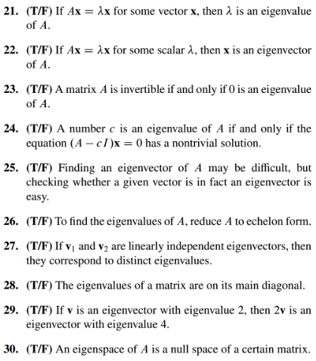

(5.1.1 solution)

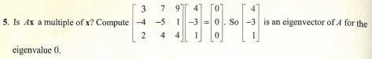

(5.1.2 solution)

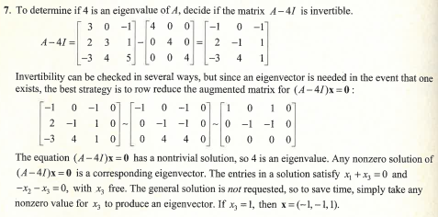

(5.1.3 solution)

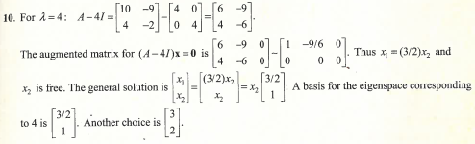

(5.1.4 solution)

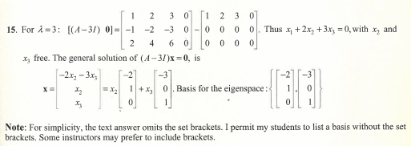

(5.1.5 solution)

Note: This solution doesn’t quite match as the A matrix students worked with includes a column of negative fives,

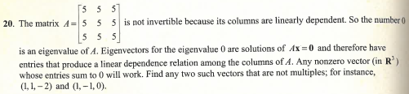

(5.1.6 solution)

