**Math 220  
4.6: Change of Basis  
Questions for flipped class**

(4.6.1)

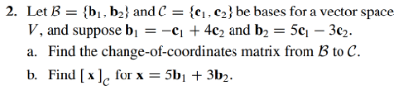

(4.6.2)





(4.6.3)

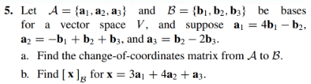

(4.6.4)





(4.6.5)

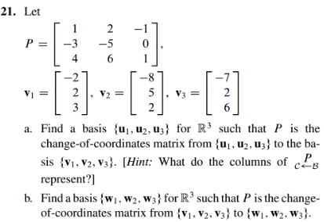

(4.6.6)

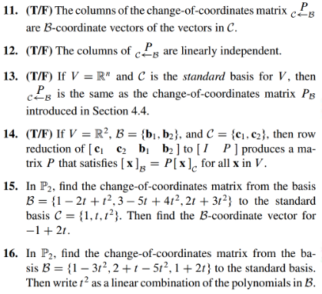

(4.6.1 solution)

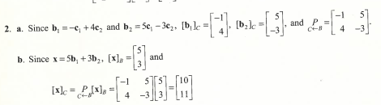

(4.6.2 solution)

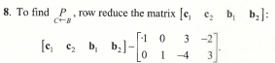

(4.6.3 solution)

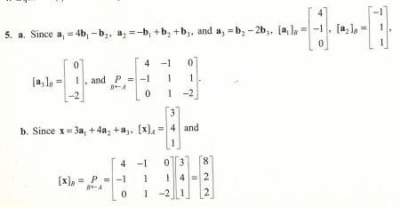

(4.6.4 solution)

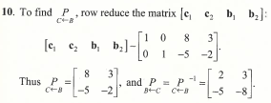

(4.6.5 solution)

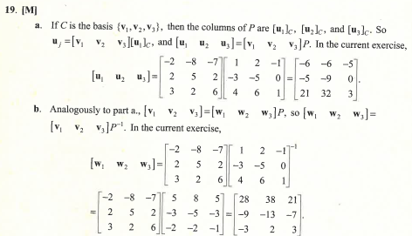

(4.6.6 solution)

