**Math 220  
4.2b: The Null and Column Space  
Questions for flipped class**

(4.2.1)

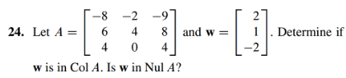

(4.2.2)

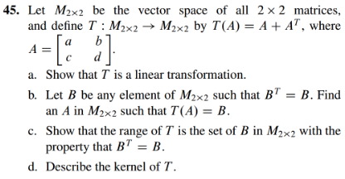

(4.2.3)

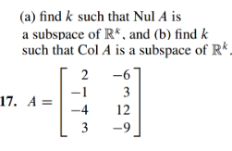

(4.2.4)

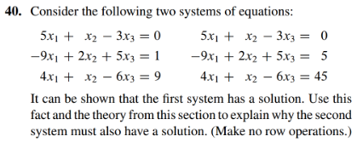

(4.2.5)

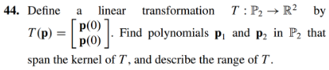

(4.2.6)

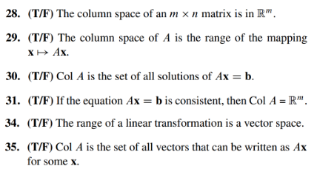

(4.2.1 solution)

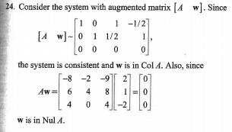

(4.2.2 solution)

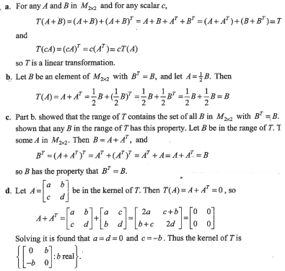

(4.2.3 solution)



(4.2.4 solution)

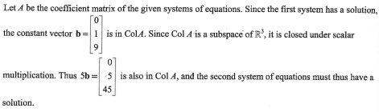

(4.2.5 solution)

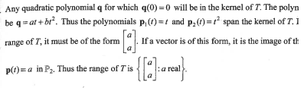

(4.2.6 solution)

