**Math 220  
2.2: The Inverse of a Matrix**

**Questions for flipped class**

**Calculator Instruction**: Use RREF to find the matrix inverse (or use the formula for 2x2 cases).

(2.2.1)

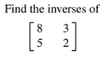

(2.2.2)

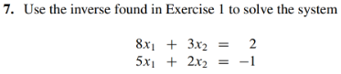

(2.2.3)



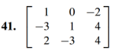

(2.2.4)



(2.2.5)



(2.2.6)

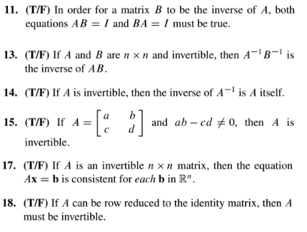

(2.2.1 solution)



(2.2.2 solution)



(2.2.3 solution)

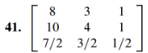

(2.2.4 solution)

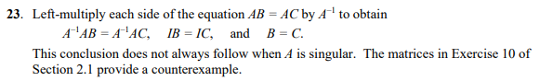

(2.2.5 solution)

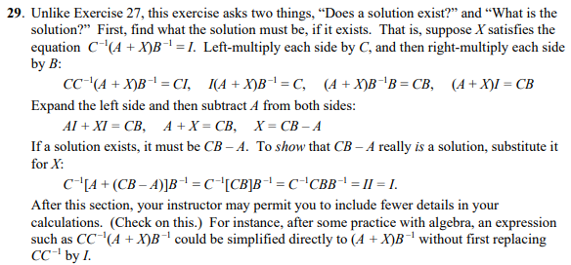

(2.2.6 solution)

