**Math 220  
2.1: Matrix Operations  
Questions for flipped class**

(2.1.1)

Compute A+2B, 3C-E, CB, and EB. If an expression is undefined, explain why  
  
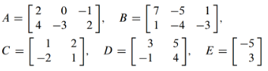

(2.1.2)



(2.1.3)



(2.1.4)

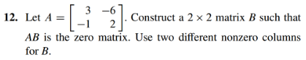

(2.1.5)

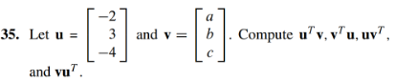

(2.1.6)

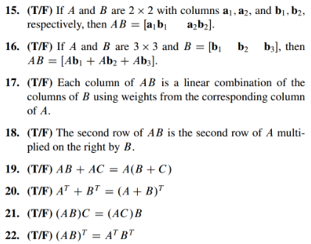

(2.1.1 solution)

* 
* 3C-E is undefined because the dimensions are not the same in C and E
* 
* EB is undefined because the dimensions are mismatched

(2.1.2 solution)



(2.1.3 solution)

*  and  but B and C aren’t equal.

(2.1.4 solution)

* Notice that column 2 is (-2)\*(col 1). So let 

(2.1.5 solution)

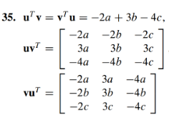

(2.1.6 solution)

