**Math 220  
1.5: Solution Sets of Linear Systems  
Questions for flipped class**

(1.5.1)

Determine if the system has a non-trivial solution. Try to use as few row operations as possible. Then write the solution set of the system in parametric vector form.

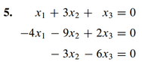

(1.5.2)





And

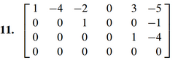

(1.5.3)



(1.5.4)





(1.5.5)

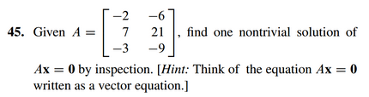

(1.5.6)

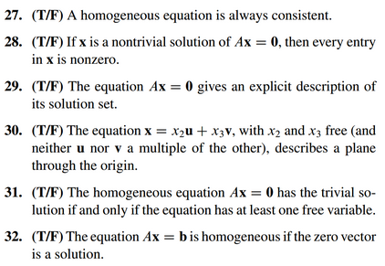

(1.5.1 solution)

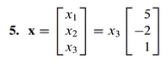

(1.5.2 solution)

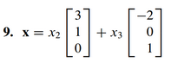

And

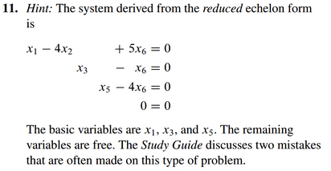

(1.5.3 solution)

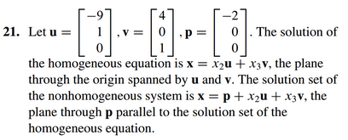

(1.5.4 solution)

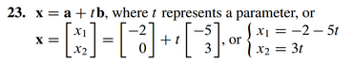

(1.5.5 solution)



(1.5.6 solution)

