**Math 220  
1.3: Vector Equations  
Questions for flipped class**

(1.3.1)

Sketch carefully and try to maintain the scale.





(1.3.2)

Write a system of equations AND augmented matrix that is equivalent to the given vector equations.

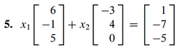

(1.3.3)



(1.3.4)

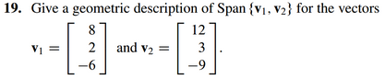

(1.3.5)

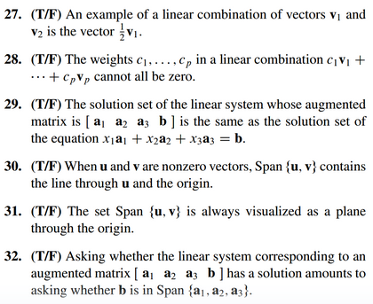

(1.3.6)

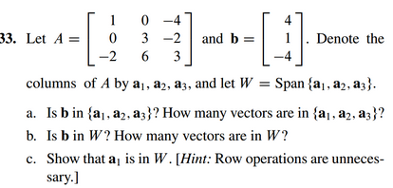

(1.3.1 solution)



(1.3.2 solution)



(1.3.3 solution)



(1.3.4 solution)



(1.3.5 solution)



(1.3.6 solution)

