**Math 220  
1.2: Row Reduction and Echelon Forms  
Questions for flipped class**

(1.2.1)

Row reduce the matrix to reduced echelon form. Circle the pivot positions in the final matrix and in the original matrix and list the pivot columns.

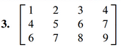

(1.2.2)

Find the general solutions of the system whose augmented matrix is given:



(1.2.3)

Find the general solutions of the system whose augmented matrix is given:

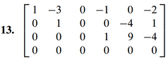

(1.2.4)

(a.)



(b.)



(c.)



(d.)



(1.2.5)



(1.2.6)

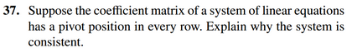

(1.2.1 solution)

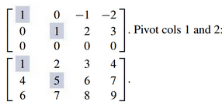

(1.2.2 solution)

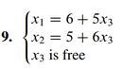

(1.2.3 solution)

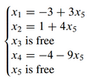

(1.2.4 solution)

a.) F – it’s unique

b.) F – the algorithm may be used on any matrix

c.) T

d.) T

(1.2.5 solution)

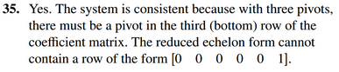

(1.2.6 solution)

