**Math 220  
1.1: Systems of Linear Equations  
Questions for flipped class**

(1.1.1)

Consider the accompanying matrix as the augmented matrix of a linear system. State in words the next two elementary row operations that should be performed in the process of solving the system.

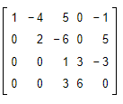

(1.1.2)

The augmented matrix of a linear system has been reduced by row operations to the form shown. Continue the appropriate row operations and describe the solution set of the original system.

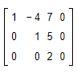

(1.1.3)

The augmented matrix of a linear system has been reduced by row operations to the form shown. Continue the appropriate row operations and describe the solution set of the original system.

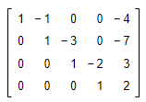

(1.1.4)

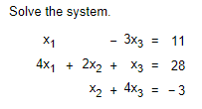

(1.1.5)

Determine the​ value(s) of h such that the matrix is the augmented matrix of a consistent linear system.

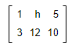

(1.1.1 solution)





(1.1.2 solution)



(1.1.3 solution)



(1.1.4 solution)



(1.1.5 solution)

