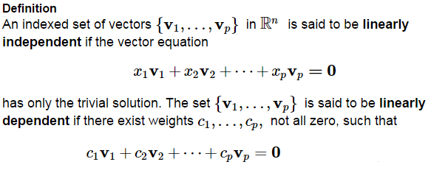

Determine whether the set is linearly independent. If not, find a linear dependence relation among .





 Determine whether the columns of the matrix are linearly independent.

Are these sets linearly dependent (LD) or linearly independent (LI) and why?

|  |  |  |
| --- | --- | --- |
| **The set** | **LD or LI** | **Why?** |
| , not the zero vector |  |  |
|  |  |  |
|  |  |  |
|  |  |  |

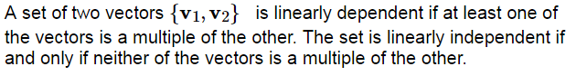

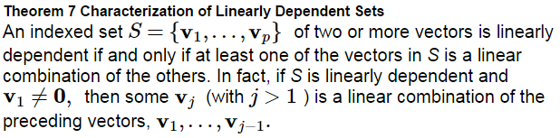

**Proof:**

Given the set of vectors  with  and  linearly independent, explain why vector  is in the plane spanned by  and  if and only if  is linearly dependent.



Proof:

Using Theorem 8, create a set of vectors in  that is linearly dependent, and don’t automatically make some of the vectors obvious multiples or combinations of the others.



Proof:

Determine by inspection if the give set is linearly dependent.

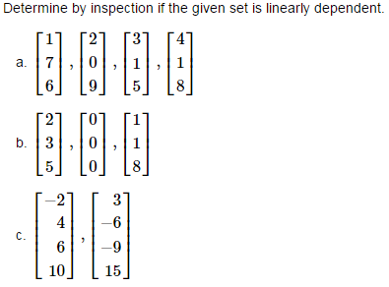

Network flow exercise from 1.6 (we did a chemistry example previously).

1. Find the general traffic pattern in the freeway network shown in the figure. (Flow rates are in cars/minute)
2. Describe the general traffic pattern when the road whose flow is is closed.
3. When  , what is the minimum value of ?

