***Directional Derivatives and the Gradient Vector***

* **Directional Derivatives**

In a previous lesson we talked about the tangent plane. To come up with the equation of the tangent plane we considered two curves on the surface, : the intersection of  and the plane  and : the intersection of  and the plane . Then we found the tangent line to these curves. But why did we pick those particular curves?

|  |  |  |
| --- | --- | --- |
|  |  |  |

The real reason that we picked them was because we only knew how to take the partial derivative parallel to our main axes, that is with respect to  and . In this section we will define partial derivatives of a function in other directions.

|  |  |
| --- | --- |
| Perhaps you recall a previous homework problem where you were asked to find  and .  But what is the meaning of these notations? Let’s give the function a story. Let’s say  represents the surface of a 3D mountain. So  is the height.  gives you the rate of change of the height in the direction of , that is how fast or slow your height changes as you walk parallel to the *x*-axis in the direction of increasing -values while passing through the point . |  |

With our current knowledge we can only find the change in height, walking in the direction of the positive -axis (East) and walking in the direction of positive -axis (North). But there are so many other directions! What if we are interested in walking in the direction NE? Directional derivative will help us with that. We generally use a unit vector to show the direction because we don’t want the length of our vector to influence our perspective of the rate of change. To understand, think about running vs. walking in direction of NE. That may influence your perspective of how fast the height of the mountain changes. Using a unit vector provides consistency.

Let . We need to find the partial derivative of this function in the direction of the unit vector  that lives on the -plane at the point . Let  be the line in the -plane that is parallel to  and passes through . This line can be represented by parametric equations:



where  is an arc-length parameter with its reference point at , and the positive direction is in the direction of . As  increases, the point  moves in the direction of  along , and a companion point  with -coordinate  moves directly above (or below) along the surface, tracing out a curve .

|  |  |
| --- | --- |
|  |  |

The rate of change of  with respect to  can be calculated using the chain rule:



Note that since then  so:



where  and  are expressed in terms of  . But  is the point on  corresponding to :



This quantity is called the **directional derivative** of at  in the direction of . We can use other notations such as .

Note that:

* If  is in the direction of the positive -axis then  so we get  and
* If  is in the direction of the positive-axis then  so we get 

So the partial derivatives with respect to  and  are just special directional derivatives.

**Theorem**: If *f* is a differentiable function of *x* and *y*, then *f* has a **directional derivative** in the direction of any unit vector  and .

**Example 1**: Find the directional derivative of  at the point  in the direction of the vector .

It is worth noting that reversing the direction of  reverses the sign of the directional derivative:



* ***The Gradient Vector***

The directional derivative formula can be expressed in the form of a dot product:



The first vector in this dot product occurs not only in computing directional derivatives but in many other contexts as well. So we give it a special name “the **gradient** of *f*” and a special notation: **grad** *f* or , which is read “del *f*.”

**Definition**: If *f* is a function of two variable *x* and *y*, then the **gradient** of *f* is the vector function  defined by .

With the gradient notation, directional derivative can be written as:  where  is a unit vector.

**Example 2**: Find the gradient of  at the point  and use it to calculate the directional derivative of  at  in the direction of the vector .

* ***Functions of Three Variables***

For functions of three variables we can define directional derivatives in a similar manner. Again  can be interpreted as the rate of change of the function in the direction of a unit vector  and 

**Example 3**: Find the gradient of  at the point  and use it to calculate the directional derivative of  at  in the direction of the vector .

* ***Significance of the Gradient Vector***

The gradient is not just a notational device to simplify the formula for the directional derivative; the length and direction of the gradient  provides important information about the function. For example, suppose is representing the surface of a mountain, that is  is the height at . If we want to know in which direction  is steepest and what that rate of change is, we need look no farther than the gradient vector. Let’s see how!

|  |  |
| --- | --- |
| * Write the dot product for directional derivative of  in the direction of  : | ________________ |
| * Rewrite this dot product using , the angle between  and : | ________________ |
| * What is magnitude of ? | ________________ |
| * Rewrite it: | ________________ |
| * What is maximum value of ? | ________________ |
| * When does it happen? | ________________ |
| * If , what is the relationship between  and ? | ________________ |
| * What can we conclude? | ________________ |

**Theorem**: Suppose *f* is a differentiable function of two or three variables. The maximum value of the directional derivative  is  and it occurs when  has the same direction as the gradient vector .

**Example 4**: Go back to example 3 and find the maximum rate of increase of  at .

**Example 5**: For the function , find the maximum value of the directional derivative at , and give a unit vector in the direction in which the maximum value occurs.

* ***The Gradient Vector and Contour Plots***

|  |  |
| --- | --- |
| **Question**: What happens to the height of a function (altitude) as you move along a level curve?  **Question**: Where is the gradient on a contour plot? |  |

From this we can make the connection that *f* has maximum rate of increase in the direction of the gradient, maximum decrease in the opposite direction, and no change when orthogonal to the gradient (along the contour line or level surface).

**Example 6a**: Consider a contour plot (topographical map) of Des Moines near Highline College.

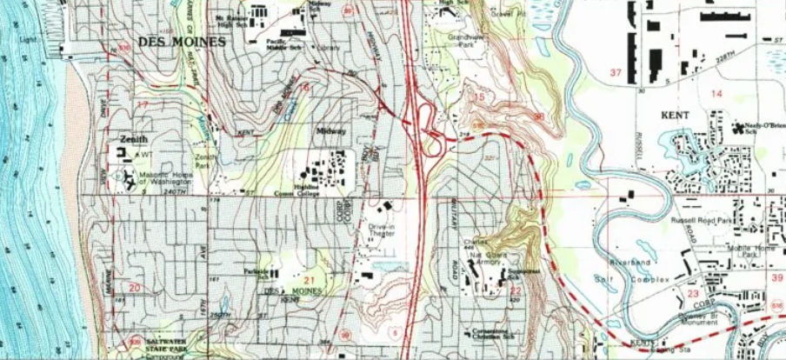

**Example 6b**: Think about peaks, ridges, valleys, and the path of steepest ascent at Mt Rainier.

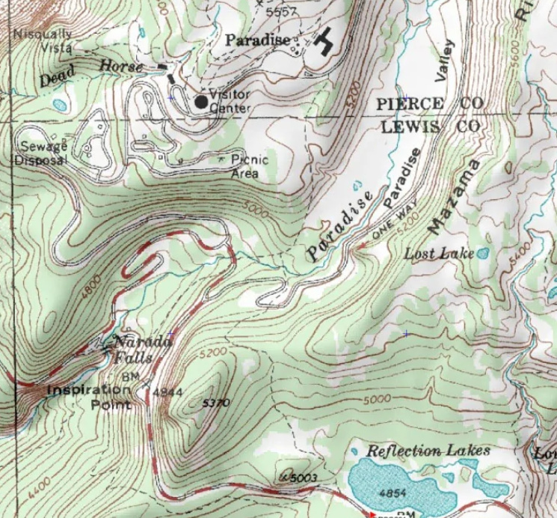

**Example 6c**: Consider the contour plot (topographical map) of the crater of Mt Saint Helens where  gives the altitude (in feet) at point  where *x* and *y* have the traditional orientation. The solid black line shows the level curve at 6,000 feet.

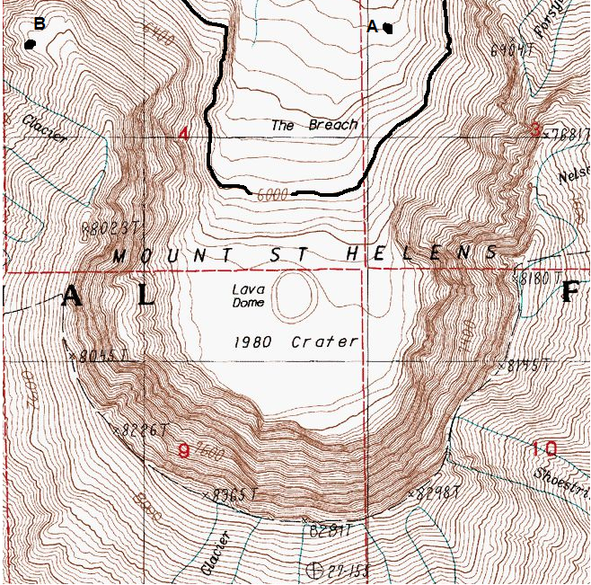

1. On the contour plot, clearly mark with a diamond ♦ the point(s) of the level curve  at which  and .
2. On the contour plot, clearly mark with a heart ♥ the point(s) of the level curve  at which the slope is shallowest ( is small).
3. Beginning at point ***A***, clearly sketch the path of steepest ascent.

Our last objective in this section is to establish a geometric relationship between the level surfaces and the gradient of a function of three variables.

Suppose we have a function  which lives in 4D. If we let  represent a constant then  is a level surface of your function which lives in 3D. Call this surface . Let  be a curve lying on . Since  is a space curve, we can define it by vector function  Since  is on  we can write . Assuming everything is differentiable, we can differentiate both sides of this equation:



Note that  and  so this equation can be written as:

 which means 

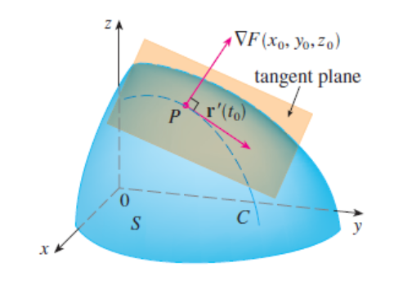Let  be a point on  with position vector . Then:



This equation says that **the gradient vector at , , is perpendicular to the tangent vector  to any curve  on  that passes through .**

If , we can define the **tangent plane to the level surface**  at  as the plane that passes through  and has normal vector . And its equation would be:



The **normal line** to  at  is the line passing through  and perpendicular to the tangent plane. Hence its direction vector will be **.** The symmetric equation of this line is:



**Example 7**: Find the equation of the plane that is tangent to the ellipsoid  at the point . What is the equation of the normal line to this ellipsoid at ?