***Equations of Lines and Planes***

In this section we will learn how to use scalar and vector products to write equations for lines, line segments and planes in space. We will use these representations in chapter 13 and Calculus IV where the basic ideas will come up repeatedly.

* **Lines and Line Segments in Space**

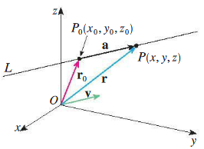In 2D, a line is determined by a point and the slope. In 3D, a line is determined by a point and the direction of the line which is described by a vector.

Suppose  is a line in space passing through a point  parallel to a vector . Then  is the set of all points for which  is parallel to . Then for some scalar **parameter** :



Note that the value of depends on the location of the point  along the line.



If  is the position vector of the arbitrary point  and  is the position vector of the point, then the vector equation of  is:

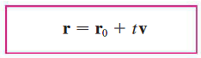

This can be written as:





Hence with , we have:



These equations are called **parametric equations** of the line *L* through the point  and parallel to the vector . Each value of the parameter *t* gives a point  on *L*. In general, if a vector  is used to describe the direction of a line *L*, then the numbers *a*, *b*, and *c* are called the **direction numbers** of *L*.

**Example 1**: Find parametric equations for the line through  parallel to . And come up with two other points on this line.

Another way of describing a line *L* is to eliminate the parameter *t* from the parametric equations. If none of *a*, *b*, and *c* is 0, we can solve each these equations for *t*, equate the results, and obtain:

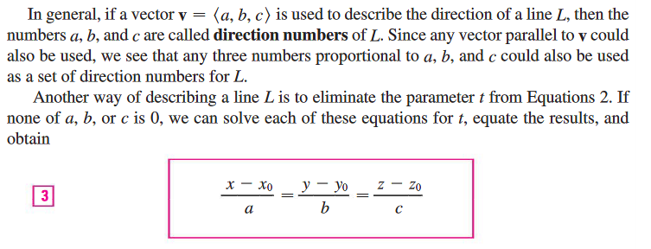

These equations are called **symmetric equations** of *L*. Notice that the numbers *a*, *b*, and *c* that appear in the denominators are the directions numbers of *L*, that is, components of a vector parallel to *L*. If one of *a*, *b*, or *c* is 0, we can still eliminate *t*. For instance if , we could write the equations of *L* as:

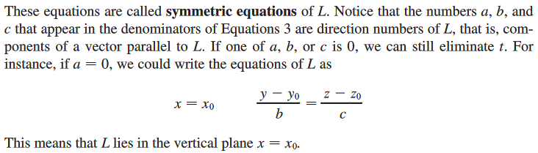

This means that *L* lies in the vertical plane .

Two lines in 3D are called **skew lines** if they don’t intersect and are not parallel!

**Example 2**: Decide if the following lines are parallel, they intersect or are skew.



**Example 3**: Suppose we have two points  and .

1. Find parametric equations for the line passing through them.

NOTE: Parametrizations are not unique!

1. Find symmetric equations of the line.
2. At what point does this line intersects the *yz*-plane?
3. Parametrize the line segment joining the two points.

|  |  |
| --- | --- |
| Suppose we want to find the equation of the line segment connecting the two points  (the “initial” point with position vector ) and  (the “end” point with position vector ). Let  then:    Where is the position vector for an arbitrary point  between  and . |  |

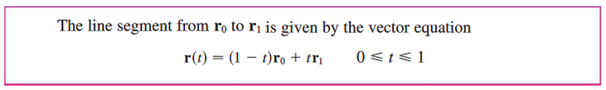

* **Equation for a Planes**

To start, let’s talk about two interesting relationships between a vector and a plane.

1. A vector is parallel to a plane if it lies on the plane, or else has no points in common with the plane. The latter happens when all the lines on the plane are either skew or parallel to that vector.
2. A vector is perpendicular to a plane if it is orthogonal to all the vectors on the plane.

Suppose you have a point and a vector.

1. How many planes exist that are parallel to the vector and include the point?
2. How many planes exist that are perpendicular to the vector and include the point?

|  |  |
| --- | --- |
| So a plane is determined by knowing a point  on the plane and its “tilt” or orientation. This “tilt” is defined by a vector that is orthogonal to the plane. This orthogonal vector  is called a **normal vector**.  Let  be an arbitrary point on the plane that contains. Then  is perpendicular to . That is: |  |

This is called the **vector equation** of the plane.

If  we can write:



This is called the **scalar equation** of the plane.

We can change the form of this equation by distributing  and . So:



Note that  is just a number.

|  |
| --- |
| So we can define the **linear equation** of the plane:  where |

NOTE: Generally we give our answers in either the form  which highlights the normal vector and a point or in the form from which we again see the normal vector and can easily find the three intercepts (assuming they all exist).

Let’s consider another form of writing the vector equation for the plane. If  is the position vector of  and  is the position vector of  then , hence:

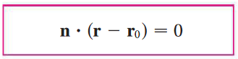

which can also be written as:

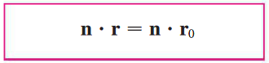

|  |
| --- |
| **Historical Note**: There are a lot of formulas in this section which makes it easy to lose track of what you are doing. At the end of the day, you are just learning about linear equations. This isn’t new; rather you’ve been exploring linear equations since pre-algebra (1 variable as in) and then in algebra (2 variables as in ) and later systems of equations (such as ). This section just expands linear into three dimensions!  In studying linear equations, you are carrying on an old tradition that spans at least Africa (Egypt), the middle-East (Babylon), Asia (China), and eventually even Europe where they caught on once they adopted algebra from the Arabs and the number system used in India.  If this sounds cool, then you are going to love linear algebra where you spend a full term studying systems of linear equations including their many applications. |

**Example 4**: Find an equation for the plane through  perpendicular to . Then find the intercepts and sketch the plane!

**Example 5**: Find an equation for the plane through  and .

* **Intersection of Planes with Lines and other Planes**

**Example 6**: What is the relationship between the line  and the plane? How would you know if they are parallel? If they intersect find the intersection point(s).

Relationships between two planes can be described as:

1. Two planes are parallel if and only if their normal vectors are parallel. That is  for some scalar .
2. 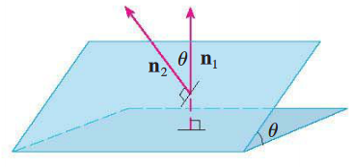Two planes that are not parallel intersect in a line. Note that the line of intersection is perpendicular to both planes’ normal vectors. That is parallel to the cross product of the two normal.
3. The angle between the two planes is defined as the acute angle between their normal vectors.

**Example 7**: Suppose we have two planes:  and .

1. Find a vector parallel to the line of intersection of the planes.
2. Find parametric equations for the intersection line.
3. Find symmetric equations for the intersection line.
4. Find the angle between the two planes.

* 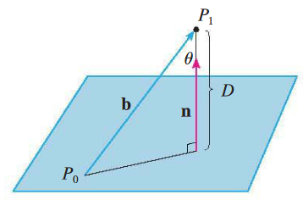**Distance between Points, Planes and Lines**

To find the distance  of the **point  to the plane** , pick a point on the plane, call it .

Then the vector connecting  to  can be found as. We know the equation of the plane so we know its normal vector . Using the given picture, we can think about distance  in two different ways:

1. Considering the right triangle, then . We also know that  is the angle between  and  so . Putting them equal to each other,  and multiplying both sides by  we get  but the dot product can be positive or negative and distance is always positive, hence we need to take the absolute value of the dot product: 
2. Considering the magnitude of the projection (component) of  onto the normal, that is: 

They are equal! So now we can find the formula for distance:



knowing , this formula can be written succinctly as: 

**Example 8**: Find the distance from  to the plane .

To find the distance between **two parallel planes**, we find any points on one plane and calculate its distance to the other plane. We do the same to find the distance **between a line and a plane** (where the line and plane are parallel).

**Example 9**: Find the distance between the parallel planes  and .

To find the distance between **two skew or parallel lines**, view the lines as lying on two parallel planes and then proceed as above. (Note that we have to find the equation of a plane that includes one of the lines and is parallel to the other.)

**Example 10**: Find the distance between the skew lines 