***The Cross Product and its Use!***

* **Cross Product**

In the previous section we learned that the dot product of two vectors is a scalar. Here we see that another way of multiplying vectors in three-dimensions, is the cross product and the result is a vector. For this reason it is also called the **vector product**.

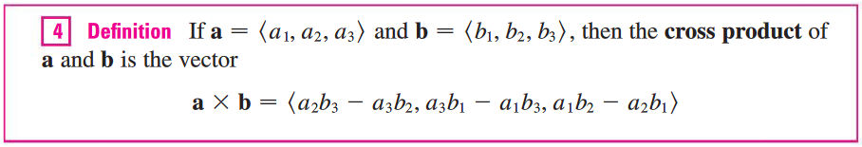

NOTE: The result of a cross product of two vectors is a vector **perpendicular** to them!

As you can see this relationship is not easy to remember so we will use notation from matrices and linear algebra called the **determinant**.

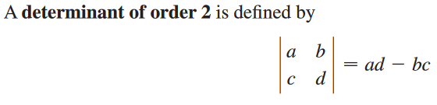

**Example 1**: Find 

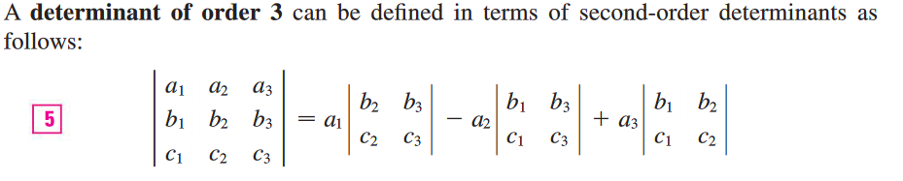

**Example 2**: Find 

The cross product of the two vectors



can be easily remembered as



**Example 3**: Find the following if  and 

1. 
2. 

What do you observe from this example?

Using the definition of cross product, show that: 

Recall from the previous section:



We can show that:



**Example 4**: Find a vector perpendicular to the plane that contains   and .

|  |  |
| --- | --- |
| If and are represented by directed line segments with the same initial point, then the cross product  points in a direction perpendicular to the plane through and . It turns out that the direction of  is given by the **right-hand rule**: If the fingers of your right hand curl in the direction of rotation (through an angle less than ) from  to , then your thumb points in the direction of . |  |

Now that we know the direction of the vector , the remaining thing we need to complete its geometric description is its length . This is given by the following theorem.

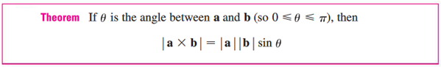

One interesting and (rarely) useful result of this is:

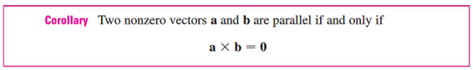

We can also interpret that:

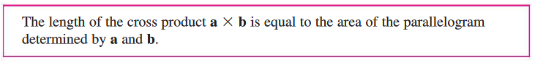

|  |  |
| --- | --- |
|  |  |

**Example 4 revisited**: Find the area of a triangle with vertices   and 

|  |  |
| --- | --- |
| **Historical Note**: In the previous section, we introduced Hermann Grassmann as one of the founders of our modern vector analysis. In about 1840, Grassmann was already able to deal with the multiplication of vectors in two- and three-dimensional spaces. He defined the **geometric product of two vectors** to be the “surface content of the parallelogram determined by these vectors” [think cross product] and the **geometric product of three vectors** [think scalar triple product that we will talk about shortly] to be the “solid (a parallelepiped) formed from them. Defining in an appropriate way the sign of such products, he was able to show that the geometrical product of two vectors is distributive and anticommutative [see the theorem below] and that the geometrical product of three vectors all lying in the same plane is zero. There is a one-to-one correspondence between Grassmann’s products and the modern cross product. The advantage of Grassmann’s method is that, unlike the cross product, it is generalizable to higher dimensions. | https://images-na.ssl-images-amazon.com/images/I/41X8HX2E9GL._SX312_BO1,204,203,200_.jpg |

If we apply these concepts to the standard basis vectors  using , we obtain:

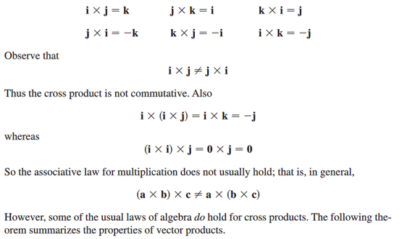

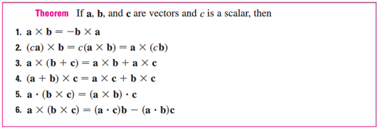

* **Scalar Triple Product**

The product  is called the **scalar triple product**. It is calculated using the determinant below. Please note that this quantity can be positive, negative, or zero.

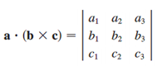

|  |  |
| --- | --- |
| The geometric significance of the scalar triple product can be seen by considering the parallelepiped determined by the vectors . The area of the base parallelogram is . If  is the angle between , then the height *h* of the parallelepiped is . (We use  instead of  in case  which cause the “height” to be negative). Therefore the volume of the parallelepiped is: |  |

Thus we have proved the formula:

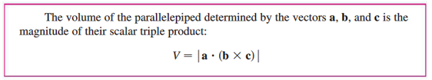

NOTE: If the parallelepiped volume is zero, then the vectors must be **coplanar** (on the same plane).

**Example 5**: Find the volume of the box (parallelepiped) determined by  and  .

* **Torque**

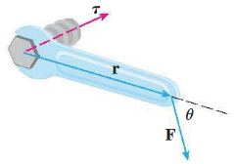When we turn a bolt by applying a force  to a wrench, we produce a torque that causes the bolt to rotate. The **torque vector** points in the direction of the axis of the bolt according to the right-hand rule. The magnitude of the torque depends on how far out on the wrench the force is applied and on how much of the force is perpendicular to the wrench at the point of application. The number we use to measure the torque’s magnitude is product of the length of the lever arm and the scalar component of  perpendicular to .

Torque Vector: 

Magnitude of Torque Vector: 

**Example 6**: Find the magnitude of the torque generated by applying a 20lb force to a 3ft bar creating a 70 degree angle.