***The Dot Product and its Use!***

* **Dot Product**

Unlike numbers, there are two ways to multiply vectors. We learn about dot product here and cross product in the next section.

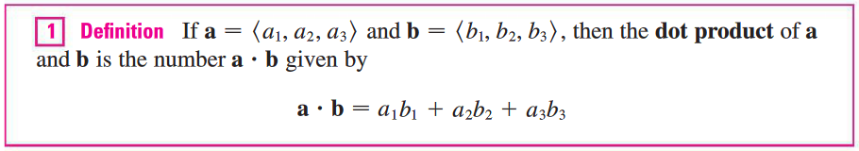

NOTE: The result of a dot product of two vectors is a scalar (number)! This is important.

**Example 1**: Find the following.

1. 
2. 

The dot product obeys many of the laws that hold for ordinary products of real numbers. These are stated in the following theorem.

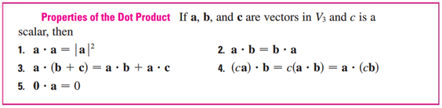

We can easily prove these properties (some are in the book).

There is an equivalent geometric definition that physicists actually use as their starting place. You can show that these are equivalent using the Law of Cosines.

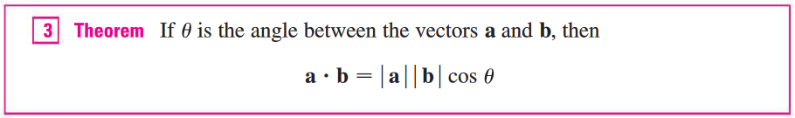

Note that the last Theorem gives you:



**Example 2**: Find the angle between  and .

|  |
| --- |
| **Teacher story**: Remember the application about the roof … well one of the authors learned this the hard way! He was sheeting a new roof (putting new wood down under the roofing material) and needed to cut some angled pieces. Being a “smart” mathematician, he used his trig skills, it was close, but not quite right! Out in the real world, he couldn’t figure out the angle!    So he did what most people would do … he used a lot of extra nails and just covered it up.  Later, he told an engineering friend about this who said, “Why didn’t you use vectors and the dot product to find the angle?”  Lesson learned. |

**Example 3**: Suppose one plane of a roof has a 6:12 pitch and it is intersected by a second plane that has a pitch of 4:12. Find the angle between the valley and a line going straight up the 6:12 roof plane.

Two nonzero vectors  and  are called **perpendicular** or **orthogonal** if the angle between them is . (Note: This is , however we focus on radians as that is the prevalent measure used throughout mathematics). Now we can calculate the dot product of the perpendicular vectors:



and conversely if , then , so . The zero vector  is considered to be perpendicular to all vectors. Therefore we have the following method for determining whether two vectors are orthogonal.

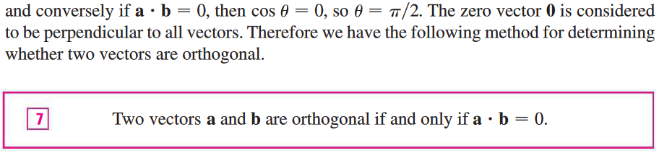

**Example 4**: Show that  and  are orthogonal.

|  |  |
| --- | --- |
|  |  |

* **Direction Angles**

The *direction angles* of a nonzero vector  are the angles in the interval , that the vector makes with the positive *x*-, *y*- and *z*-axis. The cosines of these angles are called the *direction cosines*.

NOTE: This is a topic may need for homework, but direction angles are not used heavily elsewhere.

Looking at the given figure:

|  |  |
| --- | --- |
|  |  |

This gives us: 

So: 

Which can be written as: 

Therefore: 

Also, we can see : 

**Example 5**: Find the direction angles of the vector  (Round to the nearest whole angle).

* **Projections**

Think about vector  in 2D.

We say that  is the horizontal component of vector . We can also say it is the component of vector  in the direction of *x*-axis (onto or any vector in that direction). We can write this as: .

Also we call  the shadow of  onto *x*-axis. In correct mathematical terms,  is the projection of  onto  and can be written as: 

We can define component or projection of a vector onto any other vector or in any other direction.

The**vector projection** of onto  is denoted by .

|  |  |  |  |
| --- | --- | --- | --- |
| The two cases are shown in the figure. |  | |  |
| The**scalar projection** of onto  (also called the **component** of  along ) is denoted by. It is defined to be the signed magnitude of the vector projection .  Derivation: | |  | |

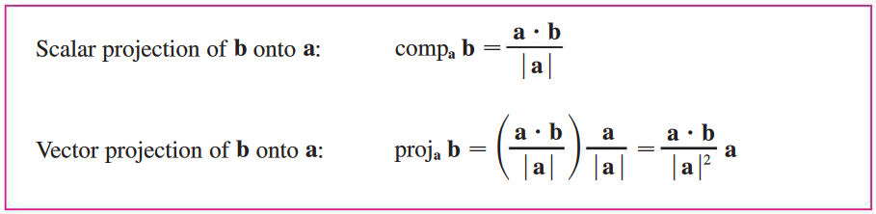

Notice that the vector projection is the scalar projection multiplied by the unit vector in the direction of vector 

**Example 6**: Find the scalar and vector projection of  onto .

* **Work**

The work done by a constant force  that moves an object from  to  (creating displacement vector ) can be calculated by:



NOTE: Force and work are major themes in the last part of Calculus IV.

**Example 7**: If   and , find the work!

**Example 8**: How much work is done if a man pulls a wagon from point  to point  by applying lbs. on the handle that makes a angle with the horizon? (Displacement is in feet)