***3D Coordinate Systems***

|  |  |  |
| --- | --- | --- |
| As of now, all of our graphs in rectangular coordinate system were two-dimensional. We were locating a point on the *xy*-plane by its ordered pair . But we live in a three-dimensional world (physically of course!). To locate a point in the space we use ordered triple and use 3 axes, *x*, *y* and *z*. These are three number lines that cross each other at their zero with angles. This point is called the origin and has coordinates. | **Historical note**: As we begin a discussion of geometric ideas, it may be helpful to learn that while you have previously learned about geometry and algebra separately, the approach we take in calculus is called analytic geometry and includes both geometry and algebra. Your skills in both areas will be useful.  Analytic geometry was born in 1637 of two fathers, Rene’ Descartes and Pierre de Fermat. Both Fermat and Descartes present the same basic techniques of relating algebra and geometry, the techniques whose further development culminated in the modern subject of analytic geometry. Both men came to the development of these techniques as part of the effort of rediscovering the “lost” Greek techniques of analysis. Both were intimately familiar with the Greek classics and in particular with Pappus. But Fermat and Descartes developed distinctly different approaches to their common subject, differences rooted in their differing points of view toward mathematics.[1] | |
| The way we like to think of their position is shown in the diagram using the right-hand rule.  The *xy*-plane is the plane that contains the *x*- and *y*-axes; the *yz*-plane is the plane that contains the *y*- and *z*-axes; and the *xz*-plane is the plane that contains the *x*- and *z*-axes. These three coordinate planes divide space into eight parts, called **octants**. The **first octant**, in the foreground, is determined by the positive axes.  The point  determines a rectangular box. If we drop a perpendicular from *P* to the *xy*-plane, we get a point  called the **projection** of *P* onto the *xy*-plane, similarly and are projections onto the ___________________ and ___________________, respectively. | |  |

In the picture below, the points  and  are plotted.

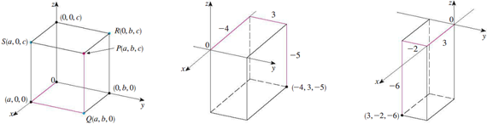

**Example 1**: Interpret these equations and inequalities geometrically in 3D.

1. 
2. 
3. 
4. 
5. 
6. 
7. Describe and sketch the surface in  represented by the equation 
8. Which points satisfy the equations and 
9. What does the equation  represent as a surface in 

To create a formula for the **distance between two points** and  in three-dimensions, assume the given sketch (left).

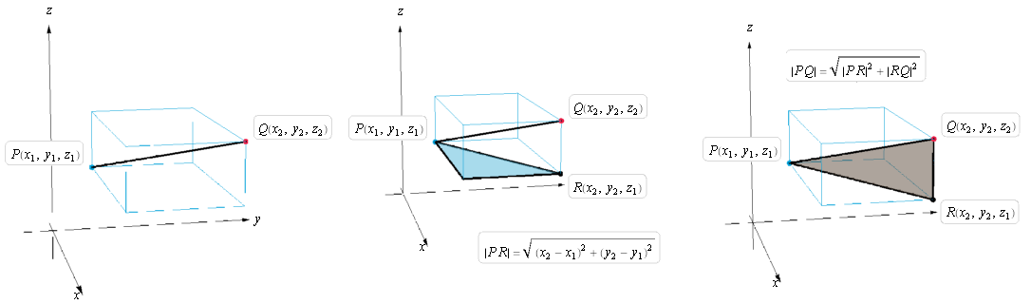



|  |
| --- |
| **Distance Formula in Three Dimensions**: The distance  between the points and  is |

**Example 2**: Find the distance between and 

A sphere of radius  and centered at  is the set of all points whose distance from  is . To find an equation for a sphere we focus on the fact that  so and hence:

|  |  |
| --- | --- |
|  |  |

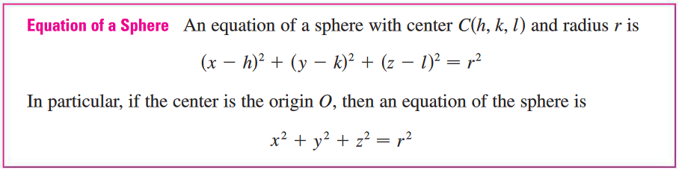

**Ex3**: Find the center and radius of the sphere: 

**Ex4**: Write an inequality to describe the solid upper hemisphere of the sphere of radius 4 centered at the origin.

1. Abridged from A History of Mathematics, 3rd Ed. By Victor Katz. Page 473.