***Curves Defined by Parametric Equations***

|  |  |
| --- | --- |
| Imagine that a particle moves along the curve *C* shown. It is impossible to describe *C* by an equation of the form  because *C* fails the vertical line test. But the *x*- and *y*-coordinates of the particle are functions of time and so we can write  and . Such a pair of equations is often a convenient way of describing a curve and gives rise to the following definition. |  |

Suppose that *x* and *y* are both given as functions of a third variable *t* (called a **parameter**) by the equations  and(called **parametric equations**). Each value of *t* determines a point , which we can plot in a coordinate plane. As *t* varies, the point  varies and traces out a curve *C*, which we call a **parametric curve**. The parameter *t* does not necessarily represent time and, in fact, we could use a letter other than *t* for the parameter. But in many applications of parametric curves, *t* , does denote time and therefore we often talk/interpret a  as the position of a particle at time *t*.

**Example 1**:

1. Sketch the parametric curve defined by the parametric equations: 

|  |  |
| --- | --- |
| 1. Eliminate the parameter to find the Cartesian equation of the parametric equations in part (a). Then use your words to describe the curve. | 1. Sketch the parametric curve defined by the parametric equations: |

In general, the curve with parametric equations  has **initial (starting) point ** and **terminal (ending)** **point **

There is an important difference between a curve, which is a set of points, and a parametric curve, in which the points are traced in a particular way.

**Example 2**:

1. Graph the parametric curve:



1. In your own words, describe this **parametric curve**.
2. Use your words to describe the **curve**.
3. Come up with its Cartesian equation.
4. Parametric equations do not uniquely represent a curve! Come up with three different set of parametric equations that gives you the same curve (“a circle centered at  with radius 2).

|  |  |
| --- | --- |
| Parametric equations of the circle with center  and radius *r* |  |

**Example 3**: Describe the motion of a particle with position  as  varies in the given interval.



Come up with its Cartesian equation, that is, eliminate the parameter.

One important uses of parametric curves is in computer-aided design (CAD). A special type of parametric curves called Bezier curves, are used extensively in manufacturing, especially in the automotive industry. These curves are also used in specifying the shapes of letters and other symbols in laser printers.

**Example 4**: Graph the following on your calculator in the window  with ; first with Tstep =, then with Tstep =.



What happens when the steps are smaller?

* ***The Cycloid***

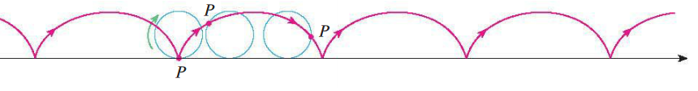Definition: The curve traced out by a point *P* on the circumference of a circle as the circle rolls along a straight line (or any curve! – your book also demonstrates it inside and outside of a circle) is called a **cycloid**.

<http://demonstrations.wolfram.com/CycloidCurves/>

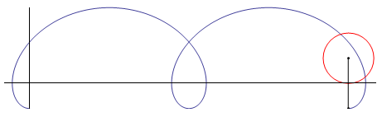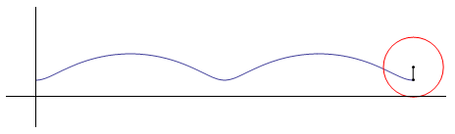 **Curtate Cycloid Prolate Cycloid**

|  |
| --- |
| **Historical note**: Galileo seems to have been the first to notice the cycloid and investigate its properties, in the early 1600’s. He didn’t actually discover any of the properties, but he gave the curve its name and recommended its study to his friends, including Mersenne in Paris. Mersenne informed Descartes and others about it, and in 1638 Descartes found a construction for the tangent. In 1644 Galileo’s disciple Torricelli (who invented the barometer) published his discovery of the area under one arch. The length of one arch was discovered in 1658 by the great English architect Christopher Wren. |

**Example 5**: If and  are fixed numbers, find parametric equations for the curve that consists of all possible positions of the point  in the figure. Use the angle  as the parameter. 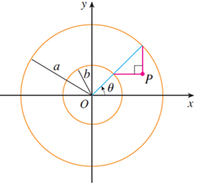

Now eliminate the parameter and identify the curve.

**Example 6:** If a circle has radius and rolls along the *x*-axis and if one position of  is the origin, find parametric equations for the cycloid created by .

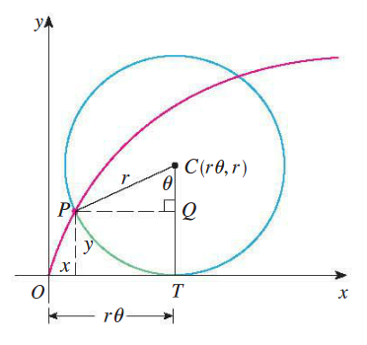

**Parametric equations of the cycloid:**



* Each arch of the cycloid corresponds to one rotation of the circle
* We can write the equation of the cycloid in terms of *x* and *y* but it is very difficult. More to the point, the Cartesian representation  is much less elegant than the parametric equations we have recently mastered.