***Conic Sections***

Conic sections are the curves we get when we make a straight cut in a cone. As shown below, there are four interesting conic sections: circles, ellipses, parabolas and hyperbolas.

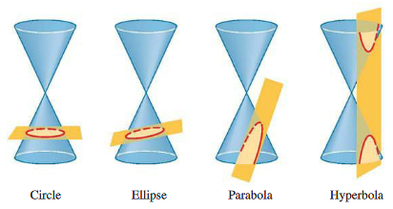

Note: The circle is a special case of the ellipse.

* **General Equation of a Conic Section**

The graph of the equationwhere and *C* are not both , is a conic.

* If or is , it’s a parabola.
* If and are equal, it’s a circle.
* If and have the same sign, it’s an ellipse.
* If and have opposite signs, it’s a hyperbola.

**Example 1**: Identify the type of conic section whose equation is given.

1. 
2. 
3. 

|  |
| --- |
| **Historical note**: The history of conic sections begins around 300 BC and continued for nearly 2,000 years. For most of this time, conics lived entirely within the realm of geometry. It was about diagrams, straight edges, angles, and constructions. But in the 1600’s, Descartes and Fermat found a way to represent geometry algebraically. A taste of this **analytic geometry** is in this section. |

* **Parabolas, a Geometric Definition**

|  |  |  |  |  |
| --- | --- | --- | --- | --- |
| A **parabola** is the set of points in the plane equidistant from a fixed point (called the **focus**) and a fixed line (called the **directrix**).  The **vertex** of the parabola is half way between the focus and the directrix. The **axis of symmetry** is the line that runs through the focus perpendicular to the directrix.  Note: Pay attention to explanations that are from geometry vs. analytic geometry. | |  | | |
| Parabola with vertical axis: The graph of the equation  is a parabola with the following properties:  Vertex:  Focus:  Directrix: |  | | | |
|  | | |  | |
|  | | | Parabola with horizontal axis: The graph of the equation  is a parabola with the following properties:  Vertex:  Focus:  Directrix: | |
| We can use the coordinates of the focus to estimate the *width* of a parabola when sketching the graph. The line segment that runs through the focus perpendicular to the axis, with end points on the parabola, is called the **latus rectum**, and its length is the **focal diameter** of the parabola. This length is . | | | |  |

* **Ellipses, a Geometric Definition**

An **ellipse** is the set of all points in the plane such that the sum of their distances from two fixed points (called the **foci**)is constant.

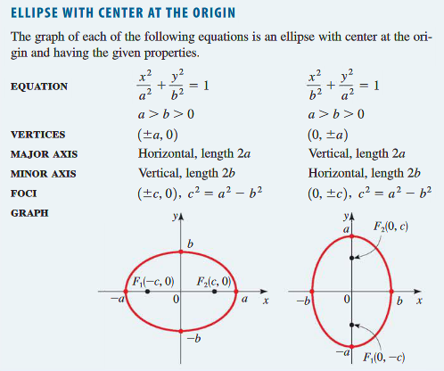

In the standard equation for an ellipse, is the larger denominator and is the smaller. To find , subtract the smaller denominator from the larger one.

**Example 2**: Find the vertices and foci of the ellipse and sketch its graph.

* **Hyperbolas, a Geometric Definition**

|  |  |
| --- | --- |
| A **hyperbola** is the set of all points in the plane such that the difference of their distances from two fixed points (called the **foci**)is constant.  The segment joining the two vertices is the **transverse axis** of the hyperbola.  The **asymptotes** are lines that the hyperbola approaches for large values of *x* and *y*. |  |

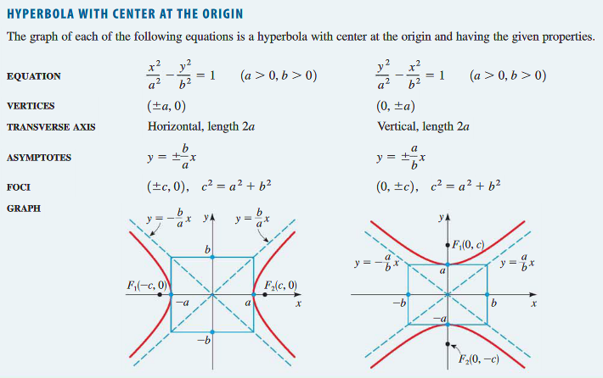

**How to Sketch a Hyperbola centered at the origin**

1. Sketch the central box. This is the rectangle centered at the origin, with sides parallel to the axes, that crosses one axis at , the other at .
2. Sketch the Asymptotes. These are the lines obtained by extending the diagonals of the central box.
3. Plot the Vertices. These are the two *x*-intercepts or the two *y*-intercepts.
4. Sketch the Hyperbola. Start at a vertex and sketch a branch of the hyperbola, approaching the asymptotes. Sketch the other branch in the same way.