**Math 163: A somewhat Historical Approach to Power Series  
PS8: Taylor Series and Approximation  
Questions for flipped class**

**(PS8.1)**

Find the Taylor polynomial  for  centered at . Graph *f* and  on the same screen. (Actually graph them! This is an easy way to know you are right and/or catch mistakes).

**(PS8.2)**

Find the Taylor polynomial  for  centered at . Graph *f* and  on the same screen. (Actually graph them! This is an easy way to know you are right and/or catch mistakes).

**(PS8.3)**

Find a second-degree Taylor polynomial approximation for  centered at  on the interval . Then use Taylor’s Inequality (aka The Remainder Estimation Theorem) to estimate the accuracy of the approximation  when *x* lies on the given interval. Check your results by graphing 

**(PS8.4)**

Find a third-degree Taylor polynomial approximation for  centered at  on the interval . Then use Taylor’s Inequality (aka The Remainder Estimation Theorem) to estimate the accuracy of the approximation  when *x* lies on the given interval. Check your results by graphing 

**(PS8.5)**

Use Taylor’s Inequality to determine the number of terms of the Maclaurin series for  that should be used to estimate  to within 0.00001.

**(PS8.6)**

How many terms of the Maclaurin series for  do you need to use to estimate  to within 0.001?

**(PS8.1 solution)**

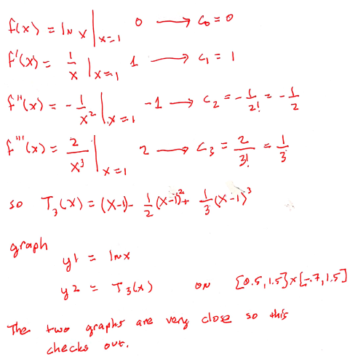

**(PS8.2 solution)**

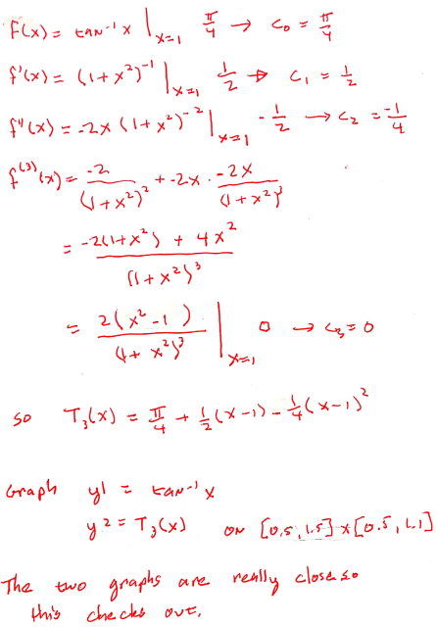

**(PS8.3 solution)**

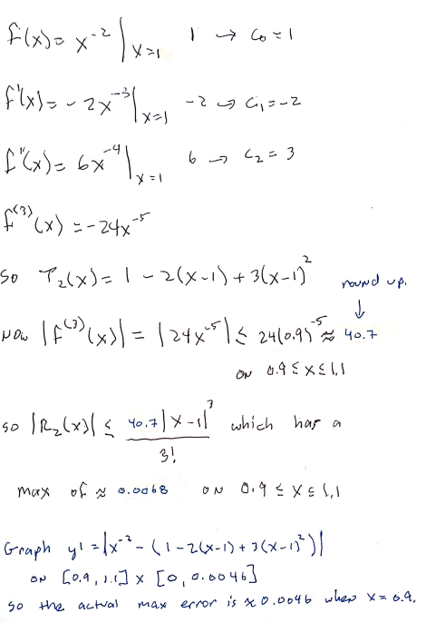

**(PS8.4 solution)**

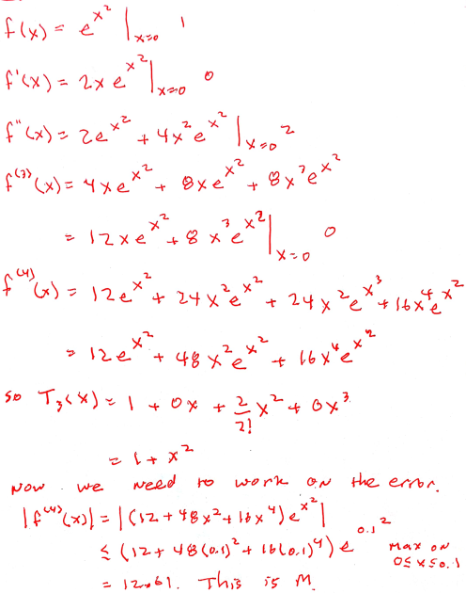

**(PS8.4 solution continued)**

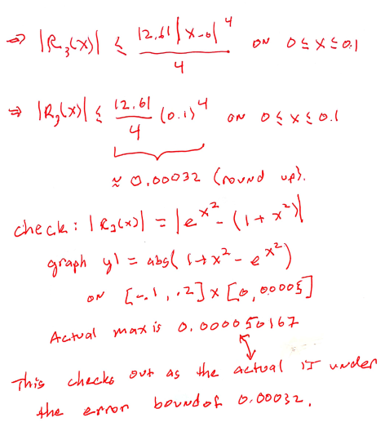

**(PS8.5 solution)**

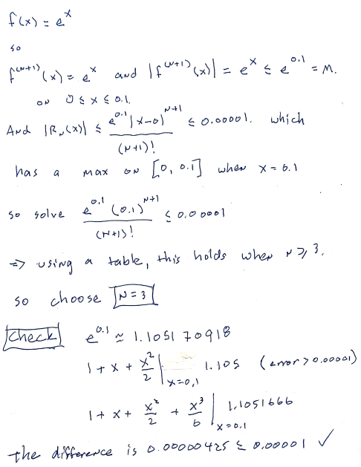

**(PS8.6 solution)**

