**Math 163: A somewhat Historical Approach to Power Series  
PS7: Taylor Series  
Questions for flipped class**

**(PS7.1)**

Find the Taylor series for  centered at 

**(PS7.2)**

Find the Taylor series for  centered at 

**(PS7.3)**

Find the Taylor series for  centered at 

**(PS7.4)**

Use a series to approximate  to four decimal places.

**(PS7.5)**

Use series to evaluate the limit 

**(PS7.6)**

Find the sum of the series 

And if you are feeling cool: Use power series to understand  where .

**(PS7.1 solution)**

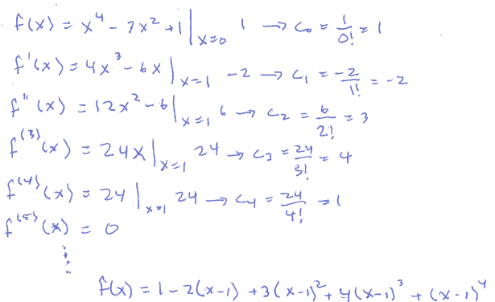

**(PS7.2 solution)**

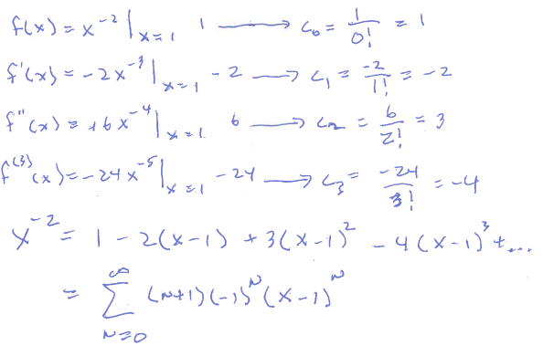

**(PS7.3 solution)**

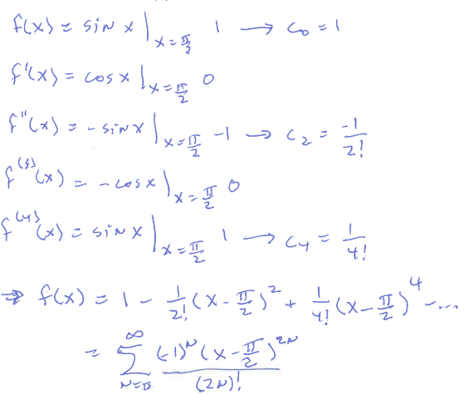

**(PS7.4 solution)**

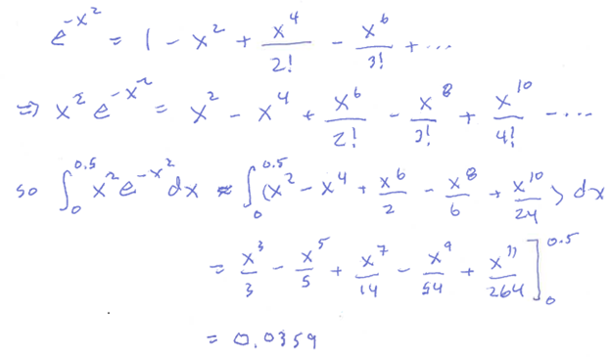

**(PS7.5 solution)**

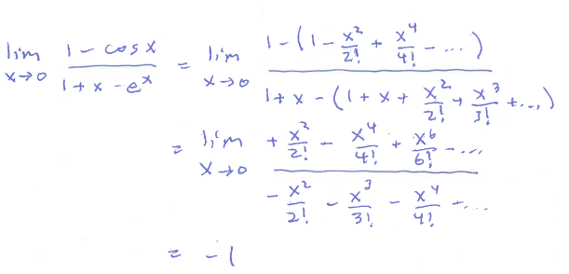

**(PS7.6 solution)**

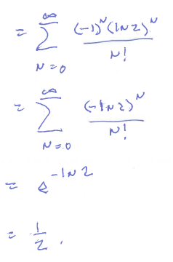

**(Bonus cool question solution)**

