**Math 163: A somewhat Historical Approach to Power Series  
PS6: Convergence and the Ratio Test  
Questions for flipped class**

**(PS6.1)**

Find the radius of convergence of 

**(PS6.2)**

Find the radius of convergence of 

**(PS6.3)**

Find the radius of convergence of 

**(PS6.4)**

Find the radius of convergence of 

**(PS6.5)**

Find the radius of convergence of 

**(PS6.6)**

Find the radius of convergence of 

**(PS6.1 solution)**

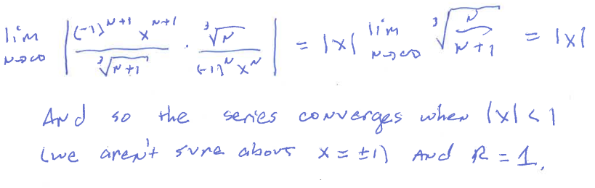

**(PS6.2 solution)**

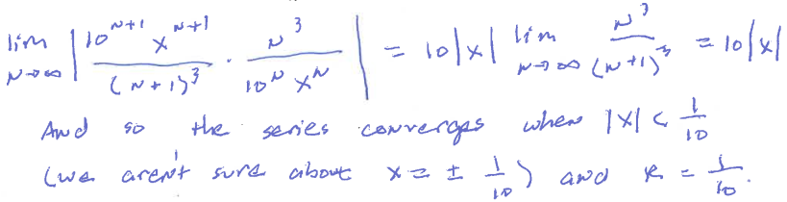

**(PS6.3 solution)**

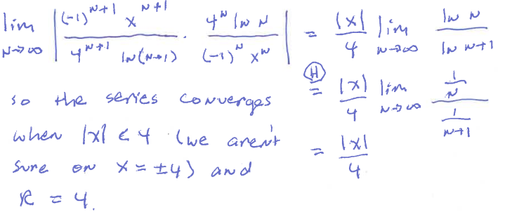

**(PS6.4 solution)**

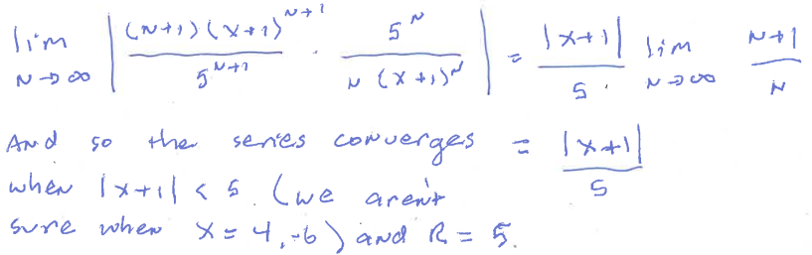

**(PS6.5 solution)**

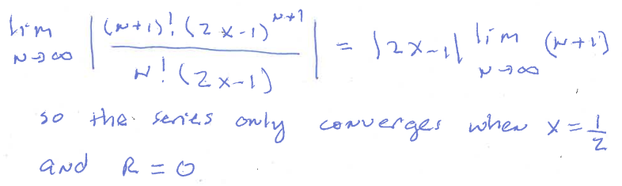

**(PS6.6 solution)**

