**Math 163: A somewhat Historical Approach to Power Series  
PS5: The Maclaurin Series  
Questions for flipped class**

**(PS5.1)**

Find the Maclaurin series for  using the definition of a Maclaurin series.

**(PS5.2)**

Find the Maclaurin series for  using the definition of a Maclaurin series.

**(PS5.3)**

Use a known Maclaurin series to obtain the Maclaurin series for the function 

**(PS5.4)**

Use a known Maclaurin series to obtain the Maclaurin series for the function  (Hint: Use a power reducing formula).

**(PS5.5)**

Use series to approximate the definite integral  to three decimal places.

**(PS5.6)**

Find the sum of the series 

**(PS5.1 solution)**

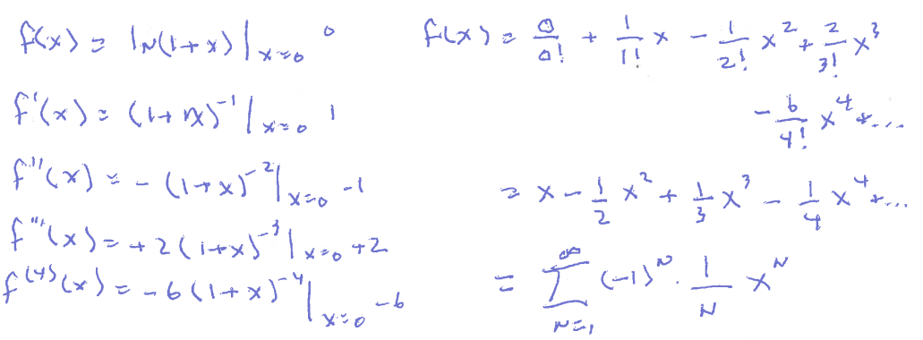

**(PS5.2 solution)**

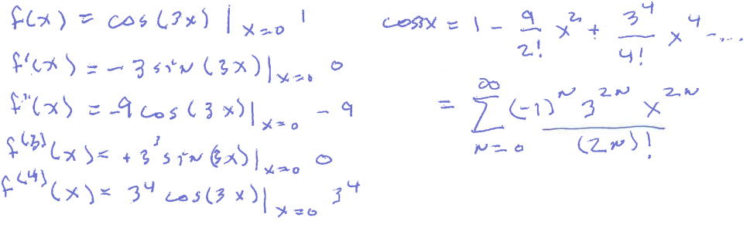

**(PS5.3 solution)**

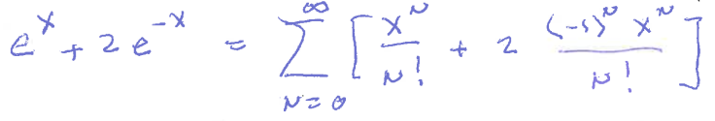

**(PS5.4 solution)**

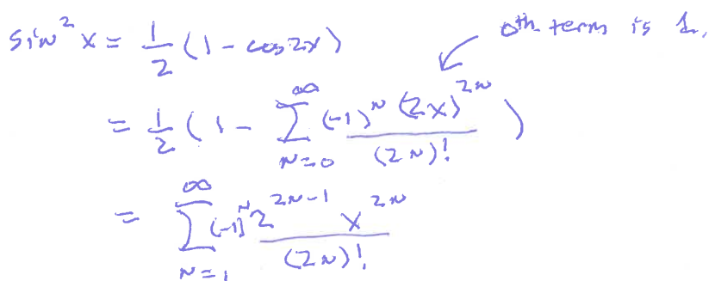

**(PS5.5 solution)**

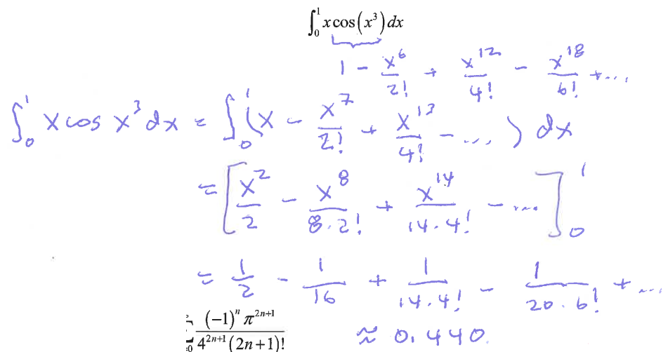

**(PS5.6 solution)**

